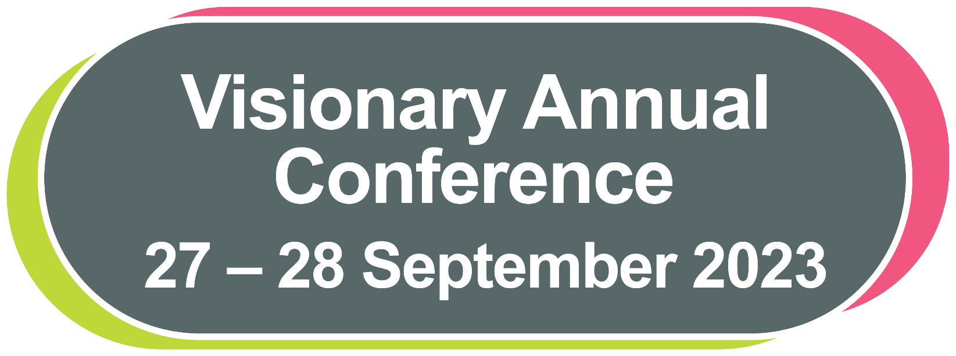

# Visionary Annual Conference

27 – 28 September 2023

## Contents

Visionary Annual Conference 1

Contents 2

Welcome 4

Annual Conference 2023: Programme 6

Tuesday 26 September 2023 6

Wednesday 27 September 2023 6

Thursday 28 September 2023 7

Join us on X (previously known as Twitter) 8

Keynote Speaker Profiles 8

Visionary Voices 11

Finding Your Way Around the Conference 12

Prayer Room and Quiet Spaces 12

Networking and Connecting with Colleagues 13

Navilens 14

Thomas Pocklington Trust 15

Conference Sponsors and Funders 16

Member 16

National Partners 17

Corporate Sponsors and Funders 22

Exhibition 2023 26

Exhibitors 26

Location of Exhibitors 32

Speaker Profiles 33

VI Charity Sector Partnership Workstream Showcase 37

Visionary Annual Awards Dinner 38

Workshops 39

Session One: Wednesday 27 September: 13:45 to 15:00 39

Session Two: Wednesday 27 September: 15:30 to 16:45 48

Session Three: Thursday 28 September: 10:30 to 11:45 57

Session Four: Thursday 28 September: 12:15 to 13:30 65

Quick Guide to using Navilens 70

Emergency Evacuation Routes 72

## Welcome

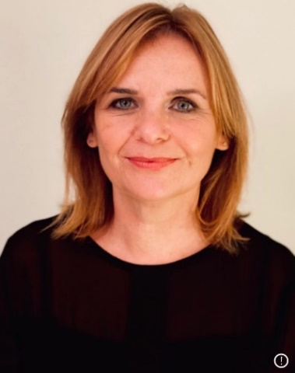  
Fiona Sandford, CEO, Visionary

**Welcome to our wonderful Visionary conference!**

Whether this is your first time, or you are a seasoned Visionary conference attendee, we are sure that you will leave the 2023 conference feeling inspired, refreshed, and full of ideas!

As some of you may have noticed, we don’t have our usual welcome from Lord Low.  Visionary has been very privileged to have Colin as our president since 2010 and in that time, he has been a huge supporter of local organisations and a powerful advocate for blind and partially sighted people. For health reasons, Colin has decided the time is right for him to retire. I am sure everyone will join me in thanking him for everything he has done for us over the years.

We have some wonderful speakers, workshops, and exhibitors for you this year.  We are honoured to be joined by Marsha De Cordova, Sam Latif and Louisa Wickham as our keynote speakers this year.  We have very much enjoyed working with them and planning this year’s opening address.  You can read more about our keynote speakers in this delegate pack and on our website. We hope you enjoy listening to the keynote addresses, learn something new from the workshops you have chosen, find something to interest you at the exhibition and we really hope you find time to speak to your colleagues and friends, old and new.  Visionary is all about peer-to-peer support, learning from each other and creating a wonderfully supportive environment and our annual conference is the time to make this happen face to face!

This year we are creating a (virtually) paperless event, therefore we will not be distributing delegate packs at registration.  The delegate pack is full of information about this year’s conference including the conference programme, sponsors, exhibition, emergency procedures and there is a reminder of the workshops at the end of the delegate pack. We have tried to include the information in order that you will require it during the event and you can also access all of the information on our website: [www.visionary.org.uk](https://eur03.safelinks.protection.outlook.com/?url=http%3A%2F%2Fwww.visionary.org.uk%2F&data=05%7C01%7Camy.pearman%40visionary.org.uk%7C3b71ea4a479d4842047b08db9ce1bc70%7C65395a073d564877b61bf53aafe53564%7C0%7C0%7C638276265557900140%7CUnknown%7CTWFpbGZsb3d8eyJWIjoiMC4wLjAwMDAiLCJQIjoiV2luMzIiLCJBTiI6Ik1haWwiLCJXVCI6Mn0%3D%7C3000%7C%7C%7C&sdata=ZGl%2FOr4bYRuTAvMqcuHjZdPYovmcaHWQ%2BewKTAegKoY%3D&reserved=0).  Every part of this year’s conference has been made possible as a result of support, sponsorship, collaboration and encouragement from colleagues across the sector and beyond – thank you.

Possibly without realising it, our members and partners are continually influencing and shaping the conference programme. We listen to everyone, identify themes, successes, and challenges across the network and all of this informs the format and content of the event. There are so many people who have generously given their time and expertise to planning and delivering workshops, facilitating sessions, hosting events, sharing ideas, providing support during the event, and supporting the Visionary team in the months leading up to the event. The list is endless, and we appreciate everyone.

This year we have a few new elements to the conference, and it would be great to know what you think.  Our panel discussions have been developed in response to themes identified by Visionary members. They provide an opportunity to learn about what is happening across the UK and how local organisations are influencing and shaping our sector. We have created themed networking at lunchtimes which we hope will assist you in meeting colleagues with shared interests.

You are invited to join our Visionary Voices to tell us what you think about the conference, your priorities for the coming year and future Visionary events.  We use your feedback to inform what we do in the year ahead, so please share your thoughts with us.  You can read more about Visionary Voices in this delegate pack.

We are a tiny staff team, so this conference and what we do throughout the year is only possible because our members and partners are so generous and supportive of Visionary.  Thank you to everyone who helps and supports us – our sector is stronger because we collaborate and work together.  A special thanks is due to the Thomas Pocklington Trust for our very generous funding package which allows us to do all that we do.

Thank you for making time to join us at this year’s event. We hope you find your time with us valuable. As you know we are a chatty bunch, so please say hello to us – we will be really happy to see you!

Fiona, Amy, Tayyaba, Nina, Raquel, Chris, Pete, Philippa and Neil (who is joining us from House of Townend throughout the event)

## Annual Conference 2023: Programme

Hello! Welcome to the Visionary Annual Conference 2023. On arrival at the conference, you will receive a personalised programme detailing your workshop selections and meeting rooms. Please ensure you attend the sessions you have registered for as we have arranged all the venue logistics based on everyone’s pre-selections.

### Tuesday 26 September 2023

16:00 – 18:00   Conference Registration Open

16:00 – 16:45 Venue Familiarisation Tour – meet at the Visionary Registration Desk

### Wednesday 27 September 2023

08:30 – 17:00 Exhibition, Networking and Registration

09:00 – 09:45 Venue Familiarisation Tour

10:30 – 12:00 Opening Address, Welcome and Keynote Speeches

12:00 – 13:45 Lunch, Networking and Exhibition

13:45 – 15:00 Workshop Session 1

15:00 – 15:30 Break and Exhibition

15:30 – 16:45 Workshop Session 2

17:00 Exhibition closes

18:45 – 19:30 Reception Drinks

19.30 (approx) Annual Awards Dinner

### Thursday 28 September 2023

09:00 – 10:15 Welcome and VI Charity Sector Partnership Showcase

10:15 – 10:30 Refreshment Break

10:30 – 11:45 Workshop Session 3

11:45 – 12:15 Refreshment Break

12:15 – 13:30 Workshop Session 4

13:35 – 13:45 Closing Remarks

13:45 – 15:00 Lunch in the Courtyard Restaurant

15:00 onwards Depart at your leisure, please don’t forget to come and say goodbye to the Visionary team!

## Join us on X (previously known as Twitter)

We are delighted you are joining us at the Visionary Annual Conference 2023.

Please join the discussion on X **@visionary_uk** and use the hashtag **#VisionaryConference23**

We would love to hear from you during the event. Tell us about the workshops you have joined, what you have enjoyed, who you have connected with, and anything else you would like to share.

We do hope you enjoy spending time with colleagues from across the Visionary network and value your time spent at the conference.

## Keynote Speaker Profiles

We hope you are as excited as we are about the different speakers, workshops and discussion panels we have taking place this year. We are thrilled to share the profiles of our speakers below (in the order that they will join the event). We have also included information about the workshop facilitators as part of the workshop summaries – but we are confident you will learn more about them during the sessions.

**Marsha de Cordova, MP**

Marsha smiling and leaning against an iron railing. Marsha is surrounded by leafy trees and a garden is behind the railings.


Marsha has served as MP for Battersea since 2017 and was previously a Labour Party councillor in Lambeth, London. In Parliament, she has been advocating for her constituents and businesses in Battersea on a range of issues including on housing, promoting a greener future, and opportunities for young people. Marsha was previously the Shadow Secretary of State for Women and Equalities from 2020 – 2021 and the Shadow Minister for Disabled People between 2017 – 2020. She has a proud history of working in the voluntary sector for over 20 years before becoming an MP.

Marsha was born with Nystagmus and is registered blind. She has dedicated much of her life to campaigning for disability rights and is passionate about equality for all.

Thank you to Specsavers for sponsoring Marsha’s attendance at the Visionary Annual Conference 2023.

**Sam Latif, Company Accessibility Leader, Procter and Gamble**

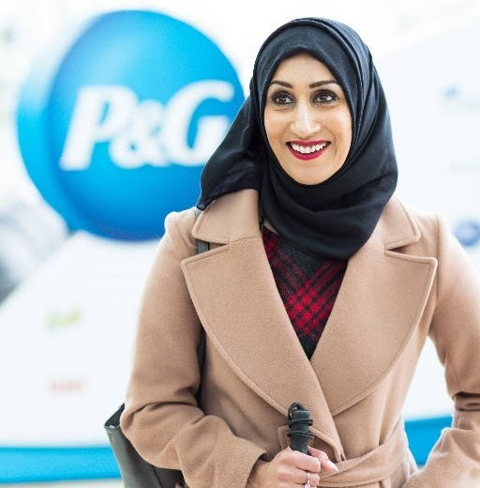

Sam Latif is P&G’s first Company Accessibility Leader – a role within which she is responsible for driving forward innovation to make the company’s 65+ brands inclusive and accessible for the 15% of people around the globe who experience some form of disability. Sam’s passion for her work stems from her personal experiences. She was born with a rare genetic condition Retinitis Pigmentosa, meaning that by the age of 16 she had lost 97% of her sight. Unwilling to let anything stop her from achieving her dreams, Sam went on to have a hugely successful IT career within P&G, joining the company in 2000.

On the side, Sam started to campaign internally for greater understanding and awareness when it comes to the challenges faced by people with disabilities – setting up an employee network for people to connect and share their experiences, as well as starting the Disability Challenge. Through this, she aimed to show senior leaders how challenging everyday tasks can be when you have a disability – from opening a pack of Pampers whilst wearing gloves to simulate dexterity challenges, through to differentiating between shampoo and conditioner when wearing glasses to simulate sight loss. In 2015, Sam switched from running IT business to focusing on embedding accessibility into P&G, and in 2019 she was promoted to Senior Director, taking on the formal title of Company Accessibility Leader.

**Louisa Wickham MBBS MD MSc FRCOphth, Medical Director & Consultant Vitreoretinal Surgeon and National Clinical Director of Ophthalmology for England**



Louisa Wickham was appointed a consultant at Moorfields in 2009. She is a vitreoretinal surgeon with a particular interest in the management of diabetic retinopathy, retinal detachment and lens dislocation surgery. She has a research degree in the surgical management of retinal detachment and post-operative scarring. She was appointed Chief Surgeon at Moorfields Eye Hospital in 2019 and during this time oversaw the Trust response to the COVID pandemic and initial recovery including COVID surgical pathways and the Moorfields Cataract Drive. Louisa was appointed Medical Director of Moorfields in 2020.

In 2022 Louisa was appointed the first National Clinical Director of Ophthalmology in England. This exciting new role was developed to provide national clinical leadership for the transformation of eye care recognising the increased burden of disease and the need to develop new pathways to reduce the risk of irreversible visual loss.

## Visionary Voices

Welcome to Visionary Voices!

Visionary Voices is an invitation for you to share your thoughts on key areas and priorities for organisation now and in the future.  Through Visionary Voices we aim to create an opportunity to come together and understand themes, challenges and exciting opportunities within the sector and beyond. We are always looking forward to hearing from you to connect, develop, inspire and collaborate with the community and we hope you will join us to share your thoughts and ideas.

We will compile the information and share in the Knowledge Hub and newsletter, to give some ideas of potential opportunities and further discussions. It will also indicate, to us, where Visionary can further support through workshops, guest speakers, events, forums and national workstreams.

If you would like to be invited to join any opportunities which arise, please include your name on the back of the post-it note.

We would also like to invite you to share in one word what Visionary means to you.  Through this we can continue to develop our work and ensure we are doing this in a way which meets the aspirations and needs of our network.

**How to do it…**

* Grab a pen and a post-it and pin it on the Visionary Voices board in the bar area of the exhibition or in the workshop rooms. You can find post-it notes in each room.
* Take a picture at the selfie station and share it with your community and tag us under the hashtag **#VisionaryConference23**. Please use the Selfie anyway – let’s tell everyone what is going on at the conference.
* Come and tell us!  We will all be able to take notes during the conference to record your thoughts.
* Raquel and Nina will also be available for you to voice record your thoughts – so please do find them and say “Hi”.

If you have any questions, please do not hesitate to ask any of the Visionary team during the conference.

## Finding Your Way Around the Conference

A huge welcome back to Conference Aston for the Visionary Annual Conference 2023!

At registration you will receive a list of your workshop selections and the meeting room for each session. To assist with accessing the different workshops, lunch and refreshments there will be a tactile map located at the Visionary Registration Desk which will be there for the duration of the event.

This year, we have arranged for the team at Conference Aston to conduct familiarisation tours of the venue, to assist with navigation around the public spaces and finding workshop rooms. If you would like to join the familiarisation tour, please meet at the Visionary registration desk at the following times:

* Tuesday 26 September at 16:00
* Wednesday 27 September at 09:00

We are delighted to welcome Utility Aid as a new sponsor for this year’s event and are extremely grateful for their support in creating this delegate pack, the development of our audio version and enabling us to use Navilens across the conference. Once again, thank you to the team at Galloways for recording the audio delegate pack.

We would also like to thank RNIB – Business Services for proving the conference information in a range of accessible formats including large print and braille. It is has been wonderful working with RNIB – Business Services to create a range of accessible information for this year’s event. To find out more please visit: [**rnib.org.uk/business**](https://www.rnib.org.uk/professionals/business-professionals/)

## Prayer Room and Quiet Spaces

During your time at Conference Aston, you are invited to visit the Martin-Luther King Multi-Faith Centre. You are very welcome to use this space for prayer, reflection, or quiet time away from the main conference. The Martin-Luther King Multi-Faith Centre is a short walk from the main entrance of Conference Aston. Please ask at the hotel reception for directions. There are male and female Islamic prayer rooms in both the main university building and the Students’ Union building. Please contact the hotel reception for opening times. For more information, please visit the Chaplaincy website:

<https://www.aston.ac.uk/current-students/health-and-wellbeing/chaplaincy>

## Networking and Connecting with Colleagues

The opportunity to network and connect with colleagues is an important element of the Visionary Annual Conference. This year, we are enhancing the networking opportunities by creating themed lunch tables on both days of the event. A number of the tables will identify core themes/topics which have been prevalent throughout the year. You are invited to join any table which is an area of interest to you. This will allow you to meet with colleagues with a shared interest. You may choose to have your main course and dessert at different tables and network with different people!

**Wednesday 27 September 2023**

* Campaigning
* CEOs and Leaders
* Children and Young People
* Income Generation
* Technology
* Volunteering

**Thursday 28 September 2023**

* Care Homes and Care at Home
* Project and Service Leads
* Rehabilitation and Habilitation
* Sensory Services
* Small Organisations
* Trustees

## Navilens

Last year we trialled the Navilens navigation app for the first time in a conference setting and are delighted to be working with Navilens, supported by Visionary members again this year. This year we are trialling their generic packages in the public areas of Conference Aston along with personalised codes to assist with networking.

**What is Navilens?**

Navilens uses a specially designed QR code that can be read from very short and long distances depending on the size of the code. Each code generated is unique, containing audio and visual text to assist with your navigation around the venue. To benefit from Navilens during the conference please download the Navilens App from Google Play or the Apple App Store.

**How will Navilens be used during the conference?**

Each delegate name badge will feature a unique code. Once you have downloaded the app you will be able to scan your name badge and name badges of other delegates. Navilens will read the person’s name, organisation and tell you how far away from you they are. You should also be able to scan a group of people and Navilens will read everyone’s name and place them in terms of distance from you.

We will also feature Navilens during lunch. Each table will feature a different code to assist with networking. In addition, each conference and meeting room used by Visionary will also have a Navilens code on the door and at the front of the room. You will be able to scan the code to make sure you are joining the correct workshop. We will also place a Navilens code on each table for dinner, so you will be able to find your table with ease.

A quick guide to using Navilens is included at the end of the delegate pack.

## Thomas Pocklington Trust

We would like to share special thanks to **Thomas Pocklington Trust**. On behalf of the Visionary team, trustees, and our entire network we are hugely grateful for the support Visionary receives from Thomas Pocklington Trust. Their support enables us to be responsive to the needs of our members, partners and in turn enhance the support available to blind and partially sighted people in local communities across the UK. We are also delighted to be joined by several colleagues from Thomas Pocklington Trust, who are facilitating workshops and sharing their work throughout this year’s event.

**About Thomas Pocklington Trust**

Thomas Pocklington Trust is a national charity dedicated to enabling and empowering blind and partially sighted people of all ages to live the life they want to lead. We are committed to increasing awareness and understanding of their needs and aspirations, to working with partners and to developing and implementing services which meet these needs to increase independence and improve lives. These include:

* Acting as an advocate and positive change agent for blind and partially sighted people.
* Creating opportunities for blind and partially sighted people seeking employment.
* Enabling opportunities and supporting blind and partially sighted people whilst in and entering education.
* Facilitating the voice and encouraging self-determination of blind and partially sighted people.
* Being an effective partner and grant funder based on our knowledge of the sector.

Website: [www.pocklington-trust.org.uk](http://www.pocklington-trust.org.uk)



## Conference Sponsors and Funders

We are looking forward to welcoming you on 27 and 28 September 2023 and hope you enjoy the keynote speakers along with participating in the workshops, presentations and panel sessions. This year we are offering more speakers and workshop options. This is a result of the fabulous support we have received from our conference sponsors and funders. We are extremely grateful to be supported by our members, partners, funders, and corporate sponsors and are honoured to share more about their organisations with you.

### Member

**Sight Scotland**

  
Sight Scotland is Scotland’s largest sight loss charity. Our diverse services span all ages and stages of sight loss and visual impairment. It also includes the Royal Blind School in Edinburgh and specialist learning services across Scotland, residential care for children and adults, community services, and research funding into sight loss conditions.

We also run the Scottish Braille Press which provides supported employment – half of the employees of the Scottish Braille Press are disabled people, including people with visual impairment. Our community services are reaching out to support even more people with sight loss in Scotland, as well as their relatives and carers.

We have a sister charity, Sight Scotland Veterans, that provides support to armed forces veterans in Scotland – including those who served National Service – who are affected by sight loss, regardless of the cause. The charity helps veterans with sight loss regain confidence, restore their independence and make new connections.

Together, our charities are determined that no one should face sight loss alone.

### National Partners

**Blind Veterans UK**

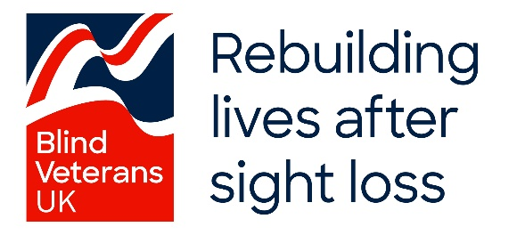

Blind Veterans UK is the national charity for ex-Service men and women with severe sight loss. Founded in 1915 in response to blinded soldiers returning from the First World War, and previously known as St Dunstan’s, Blind Veterans UK has supported tens of thousands of Armed Forces and National Service veterans to rebuild their lives after sight loss.

The charity knows that there are thousands of blind veterans out there who could be entitled to its support but are not receiving it. While Blind Veterans UK initially cared for veterans blinded in active Service, today they help veterans no matter what caused their sight loss. They help veterans to learn vital life skills and give them the tools they need to be safe in their own homes. Giving veterans free rehabilitation, training and support they need to live independent lives.

Blind Veterans UK has a network of local support teams all over the UK who give blind veterans the rehabilitation and training they need closer to them, either in their own home, their local area, or remotely. They also have two dedicated centres supporting wellbeing in all aspects of blind veterans’ lives including holidays and respite breaks. As well as providing free specialist equipment, the charity also supports veterans to find new hobbies such as art and other creative activities.

If you or someone you know is entitled to Blind Veterans UK’s free support then please call 0800 389 7979 or visit [blindveterans.org.uk](https://eur03.safelinks.protection.outlook.com/?url=http%3A%2F%2Fwww.blindveterans.org.uk%2F&data=05%7C01%7Camy.pearman%40visionary.org.uk%7Cd5ff7b4564d34cca5dd208db672a5e45%7C65395a073d564877b61bf53aafe53564%7C0%7C0%7C638217203904236530%7CUnknown%7CTWFpbGZsb3d8eyJWIjoiMC4wLjAwMDAiLCJQIjoiV2luMzIiLCJBTiI6Ik1haWwiLCJXVCI6Mn0%3D%7C3000%7C%7C%7C&sdata=iTwTbMAfVYCXgRtz4e2gL%2BZLIkQM%2Fn%2FWEdm781GdBTo%3D&reserved=0).

**Fight for Sight & Vision Foundation**

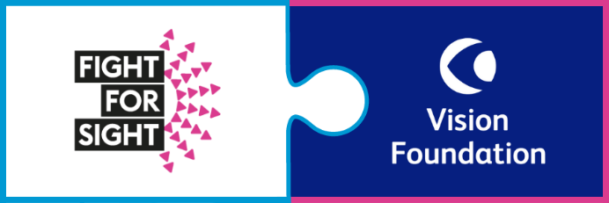

Fight for Sight & Vision Foundation came together in an ambitious merger in April 2023 with a shared mission; to save sight and change lives. Together, we offer a unique proposition as a grantmaker with a mission to solve two urgent questions:

* How do we prevent sight loss?
* And how do we empower people with sight loss to live their lives as equal citizens?

In our mission to end sight loss, we fund ground-breaking research and develop scientific talent from early career researchers. We exist to advance treatments that end sight loss. We protect and grow the community of world-class scientists, technologists, and data scientists across different condition types who will fund tomorrow’s breakthroughs.

As a growing mission-driven community of blind, visually impaired, and sighted people, we are on the move. We are determined to achieve equity in society for people with sight loss. We fund grassroots projects through grantees while delivering blueprints for change so that the impact we fund can be scaled nationwide. Through the evidence we gather scientifically and through social outreach, we influence policy and decision-making to ensure equality for all.

**Guide Dogs UK**

[Guide Dogs UK logo in navy blue.  A paw print to the left and Guide Dogs text to the right.
](http://www.guidedogs.org.uk)

Guide Dogs’ aim is to help people with sight loss live actively, independently, and well. Children and adults, friends and family. We do this through a combination of information, advice and guidance and a range of holistic, person-centred services provided by our expert staff, volunteers and life-changing dogs.

Three years on from the pandemic we marvel at the innovation, collaboration and partnership that continues to flourish across our sector. The Visionary conference provides a wonderful opportunity for us all to celebrate these developments and the generosity with which new ideas are shared with others, which is why Guide Dogs is delighted to be sponsoring the Develop and Share Award.

**Macular Society**

[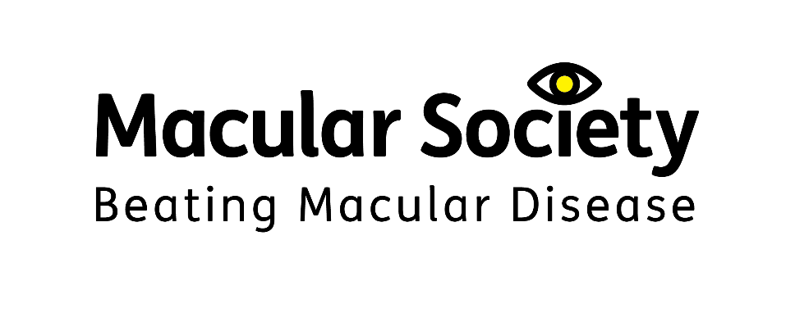](http://www.macularsociety.org.uk)  
Macular disease is the biggest cause of sight loss in the UK, with around 300 people diagnosed every day. The Macular Society is determined to beat the fear and isolation of macular disease with world-class research, and the best advice and support.

The Macular Society works in close collaboration with local and regional sight loss organisations, and the members of Visionary, to support people affected by this devastating condition and to beat macular disease, for good. The conference is a great opportunity to share experiences and learn from each other, in order to continue to improve the lives of those living with sight loss.

**RNIB (Royal National Institute of Blind People)**

[](http://www.rnib.org.uk)  
RNIB is one of the UK’s leading national sight loss charities supporting blind and partially sighted people. Our vision is a world where blind and partially sighted people can participate equitably. We recognise everyone’s unique experience of sight loss and offer help and support to people. This can be anything from practical and emotional support, campaigning for change, reading services and the products we offer in our online shop. We’re a catalyst for change – inspiring people with sight loss to transform their own personal experience, their community and, ultimately, society as a whole. Our focus is on giving them the help, support and tools they need to realise their aspirations.

RNIB is delighted to sponsor and support the Visionary Annual Conference. We wish to build stronger more productive relationships at a local level and are seeking to engage with local sight loss charities to provide more opportunities for blind and partially sighted people and improve equity of access. Opportunities include sharing information, training, support, resources etc. where RNIB is actively seeking to collaborate. If you are interested in having a discussion, please get in touch with the team via email at [charity.partners@rnib.org.uk](mailto:charity.partners@rnib.org.uk)

**RNIB – Business Services**



The Royal National Institute of Blind People (RNIB) is the largest sight loss charity in the UK. At RNIB, we are passionate about accessibility and usability. This includes supporting local societies and charities to use our services and ensure blind and partially sighted people have the information they need in their required reading format.

We are pleased to be supporting this year’s Visionary conference by providing the conference information in a range of accessible formats including large print and braille.

Our experts are here to ensure businesses websites, apps, products and services not only comply with current legislation, but are accessible and inclusive to all users.

Through web audits, user testing, training, accessible design and consultancy, we aim to help businesses maximise the value of their products and services through a tailored approach. To find out more please visit: [**rnib.org.uk/business**](https://www.rnib.org.uk/professionals/business-professionals/)

**See Sport Differently**



See Sport Differently is a Sport England funded initiative in partnership with RNIB and British Blind Sport. We want more people with sight loss to get involved and feel the benefits as participants or spectators.

Research shows that blind and partially sighted people are twice as likely to be inactive compared to people without sight loss. We want to change this.

Based on insights from blind and partially sighted people, we have developed a programme of activity to tackle the biggest barriers that stop blind and partially people from getting involved in sport and activity.

Through See Sport Differently we are determined to challenge perceptions about sport and sight loss, so that blind and partially sighted people can get involved however they want to.

### Corporate Sponsors and Funders

**Associated Optical**



Since 1983 Associated Optical, Eschenbach’s UK partner, has sought to provide eye-care professionals with innovative magnification devices to further enhance their patient care. Working closely with all of our key manufacturers and education team, our aim is to inspire our customers to further improve people’s lives using patient-centred optical solutions.

Our key brands include Eschenbach Optik for Optical and Digital magnification, Ocutech Bioptics & LiveEyewear for Cocoons FitOvers and Filters.

**Bayer**



Bayer plc has provided sponsorship funding to the Visionary Annual Conference 2023.

[www.bayer.co.uk](http://www.bayer.co.uk)

**Motability Foundation**

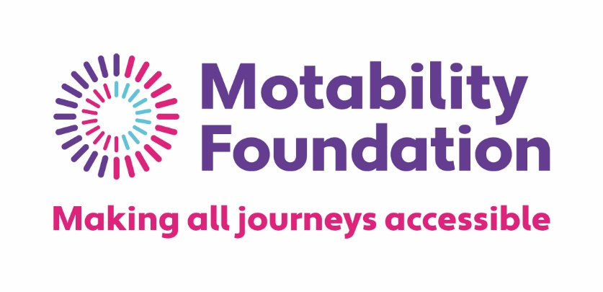

At the Motability Foundation we fund, support, research and innovate so that all disabled people can make the journeys they choose. We oversee the Mobility Scheme and provide grants to help people use it, providing access to transport to hundreds of thousands of people a year.

Working with others is a huge part of our commitment to improving accessible travel, today and in the future. We help fund other charities and organisations who give disabled people everyday transport options, from community buses to wheelchairs. We provide research grants to better understand the ways transport accessibility needs to change – funding long-term projects like the National Centre for Accessible Transport.

We also use our own research, and work with disability experts, partners and policy makers, to keep exploring and developing new ways to make all transport accessible. Such as making sure all electric vehicle charging points meet the needs of disabled people.

We never stop working alongside disabled people to make sure that their knowledge and experience shapes all of our work.

**Roche UK**



At Roche UK, we focus our energy and investment in developing tests and treatments that change lives and give us more quality time with the people we love. And, together with others, we’re solving healthcare’s greatest challenges; helping to achieve better results by connecting early diagnosis to targeted treatment and ongoing support. We have provided financial support for the organisation of Visionary’s Annual Conference 2023, but have had no input into the creation of it.

**Specsavers**

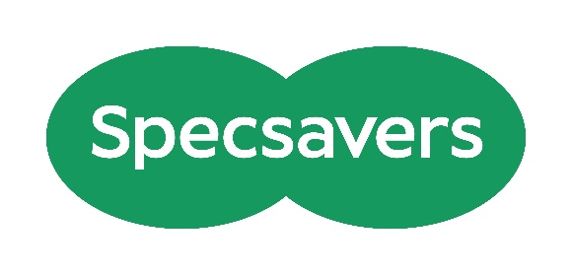

As the leading provider of optometry services for NHS Primary Care and the largest provider of community audiology services, Specsavers changes lives through better sight and hearing. Each practice is owned and run by experts who care for communities throughout the UK. There are currently more than 2,165 optics, audiology, domiciliary and ophthalmology businesses with more than 41,000 dedicated colleagues throughout the UK, Ireland, Norway, Sweden, Denmark, Finland, Spain, Australia, New Zealand and Canada and this year we have cared for more than 40 million people worldwide. For more information visit [www.specsavers.co.uk](https://eur03.safelinks.protection.outlook.com/?url=http%3A%2F%2Fwww.specsavers.co.uk%2F&data=05%7C01%7Camy.pearman%40visionary.org.uk%7C46c12bf9bc9141a4a23a08db88b17ca7%7C65395a073d564877b61bf53aafe53564%7C0%7C0%7C638254068107495904%7CUnknown%7CTWFpbGZsb3d8eyJWIjoiMC4wLjAwMDAiLCJQIjoiV2luMzIiLCJBTiI6Ik1haWwiLCJXVCI6Mn0%3D%7C3000%7C%7C%7C&sdata=FOrqehIdrZLlBrWytuXg1%2FJMkHtxdzbIFPNFjcw4M%2B8%3D&reserved=0)

**The Powell Family Foundation**

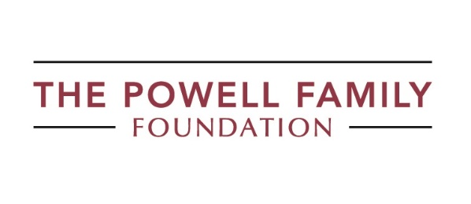

We provide grants to individuals and charities, with the aim of creating opportunities for blind and vision impaired children and young people to reach their full potential.

To find out how to apply for a grant or to contact us to discuss how we may be able to help, please complete our online contact form: <https://tpff.org.uk/contact-us/>

**Together.ly**



Together.ly is a software platform that helps charities supporting people who are older, disabled or vulnerable, to reduce loneliness and isolation by enabling them to remotely deliver social interactions, establish connections and build communities.

Utilising both the telephone and the internet, Together.ly proprietary software is simple to use and designed to meet the accessibility and safeguarding requirements of a vulnerable audience, enabling care providers to easily reach the people that need it the most.

**Utility Aid**



Utility Aid is the UK’s largest energy broker for the not-for-profit sector, and we are delighted to be one of the sponsors for the Visionary Annual Conference. We are passionate about helping our customers become greener, save time, and save money. Their dedicated team provide a high-level service to manage and maintain your portfolio, covering Procurement, Bureau Services, Full Account Management, Historical Audits, Carbon Reporting and Net Zero Planning. They have saved their charity customers over £4.7m through their invoice validation services.

## Exhibition 2023

## Exhibitors

Welcome to this year’s exhibition. Here you will find everything you need to know about the 2023 Exhibition and the amazing organisations joining us on Wednesday 27 September. As ever, we are delighted to be hosting a range of exhibitors, some for the first time. The exhibition is open from 8.30am to 5.00pm on Wednesday 27 September 2023 Several of the exhibitors are also attending workshops as well as the annual awards dinner, so there is plenty of opportunity to network and explore collaborations.

**Stand 1- Optelec UK**

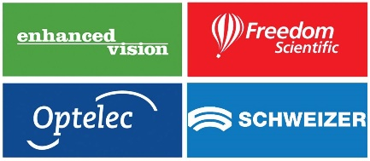

Optelec are one of the UK’s leading manufacturers of Low Vision Solutions. Our four brands cover the full spectrum of Low Vision, from newly diagnosed to complete Blindness.

Optelec – Manufacturers of Electronic Magnifiers, Braille and Text-to-Speech readers for over 40 years.

Enhanced Vision – A world leader in low vision aids, renowned for the first ever head worn electronic magnifier, the Jordy.

Freedom Scientific – Best known for world leading software including Jaws and ZoomText as well as Braille Displays.

Schweizer – Although not a Vispero brand we are proud to be the exclusive UK dealer. Schweizer have manufactured optical magnifiers for over 180 years in Germany.

Our mission is simple, we want to supply the best suited equipment for a particular individual to enhance and give independence.

Please look at our range of optical magnifiers, lighting, electronic magnifiers, reading machines and much more at: [www.lowvisionshop.co.uk](http://www.lowvisionshop.co.uk/) or Freephone 0800 145 6115

**Stand 2 – Blind Ambition**



Blind Ambition is the single-minded determination to achieve your goals. For visually-impaired people facing many barriers, a focused determination is essential to success. We want organisations and clients to harness our momentum to achieve their goals.

We support people of all ages living with visual impairment within the UK and globally and offer a wide range of services for businesses, charities and visually-impaired individuals. From training businesses to feel more confident to employ visually-impaired staff to supporting visually-impaired individuals with writing their CVs, we are here to make a difference. Businesses and charities can access: Visual Awareness Training, Disability Awareness Training, Equality, Diversity and Inclusion Training, Disability Confidence, Passenger Assistance Training, Unconscious Bias Training. Visually impaired individuals can access (free of charge): Monthly Webinars for VI workers and entrepreneurs, Employment Coaching Webinars (In collaboration with the RNIB), Confidence and Resilience Training (In collaboration with a Clinical Psychologist), LinkedIn Training Courses (In collaboration with a LinkedIn Expert), CV Writing.

For more information, call us on 020 3886 2020.

Email us at: [contact@blindambition.co.uk](mailto:contact@blindambition.co.uk)

Visit our website: [www.blindambition.co.uk](https://eur03.safelinks.protection.outlook.com/?url=http%3A%2F%2Fwww.blindambition.co.uk%2F&data=05%7C01%7Craquel.garrido-soriano%40visionary.org.uk%7C99f1d8bb2a4d4b083acf08db76f284cf%7C65395a073d564877b61bf53aafe53564%7C0%7C0%7C638234556225745969%7CUnknown%7CTWFpbGZsb3d8eyJWIjoiMC4wLjAwMDAiLCJQIjoiV2luMzIiLCJBTiI6Ik1haWwiLCJXVCI6Mn0%3D%7C3000%7C%7C%7C&sdata=7cXgzBwwt0iGLOPVgUhDAdltf4fX%2BGWoXn9Qvmj4XoM%3D&reserved=0)

Instagram: [@seemaflower_blindambitionuk](https://eur03.safelinks.protection.outlook.com/?url=https%3A%2F%2Fwww.instagram.com%2Fseemaflower_blindambitionuk%2F&data=05%7C01%7Craquel.garrido-soriano%40visionary.org.uk%7C99f1d8bb2a4d4b083acf08db76f284cf%7C65395a073d564877b61bf53aafe53564%7C0%7C0%7C638234556225745969%7CUnknown%7CTWFpbGZsb3d8eyJWIjoiMC4wLjAwMDAiLCJQIjoiV2luMzIiLCJBTiI6Ik1haWwiLCJXVCI6Mn0%3D%7C3000%7C%7C%7C&sdata=7dVOL5o8tKt8vLjkFC7eDL6m27%2BbR7MOTIWWLcOYiXc%3D&reserved=0)

Facebook: [Seema Flower](https://eur03.safelinks.protection.outlook.com/?url=https%3A%2F%2Fwww.facebook.com%2Fseema.flower&data=05%7C01%7Craquel.garrido-soriano%40visionary.org.uk%7C99f1d8bb2a4d4b083acf08db76f284cf%7C65395a073d564877b61bf53aafe53564%7C0%7C0%7C638234556225745969%7CUnknown%7CTWFpbGZsb3d8eyJWIjoiMC4wLjAwMDAiLCJQIjoiV2luMzIiLCJBTiI6Ik1haWwiLCJXVCI6Mn0%3D%7C3000%7C%7C%7C&sdata=uQZdgy753PCIsaAbblAOjTequvkLyKZJP%2FaPkczp%2Bko%3D&reserved=0)

X (formerly Twitter): [@BlindAmbition88](https://eur03.safelinks.protection.outlook.com/?url=https%3A%2F%2Ftwitter.com%2FBlindAmbition88&data=05%7C01%7Craquel.garrido-soriano%40visionary.org.uk%7C99f1d8bb2a4d4b083acf08db76f284cf%7C65395a073d564877b61bf53aafe53564%7C0%7C0%7C638234556225902193%7CUnknown%7CTWFpbGZsb3d8eyJWIjoiMC4wLjAwMDAiLCJQIjoiV2luMzIiLCJBTiI6Ik1haWwiLCJXVCI6Mn0%3D%7C3000%7C%7C%7C&sdata=CgoXxV4JeaPXKJqWP8XdaEG3MyjH8m16OtPmXzR08xA%3D&reserved=0)

LinkedIn: [Blind Ambition](https://eur03.safelinks.protection.outlook.com/?url=https%3A%2F%2Fwww.linkedin.com%2Fcompany%2F20034416&data=05%7C01%7Craquel.garrido-soriano%40visionary.org.uk%7C99f1d8bb2a4d4b083acf08db76f284cf%7C65395a073d564877b61bf53aafe53564%7C0%7C0%7C638234556225902193%7CUnknown%7CTWFpbGZsb3d8eyJWIjoiMC4wLjAwMDAiLCJQIjoiV2luMzIiLCJBTiI6Ik1haWwiLCJXVCI6Mn0%3D%7C3000%7C%7C%7C&sdata=xEfcr1X00mPJ4AJDMJrMksL%2Fi2h3Lo2SmcYhaX3PNMs%3D&reserved=0)

**Stand 3 – Guide Dogs UK**



Guide Dogs understands that sight loss is different for everyone, adult or child, sight loss can also impact those around us, Guide Dogs range of services reflect that. By understanding what the person wants from life today and tomorrow we can equip the person with the skills that they need to live an independent and active life. We’re here to support people with sight loss to live the life they choose.

**Stand 4 – Charitek**



Compass is a comprehensive on-line platform developed by the Third Sector for the Third Sector. It also comes with many other functions that organisations may find useful. It’s structure also gives each organisation full control over their part of the site so that it can be customised to your requirements. We look forward to working with you because working together works for everyone.

**Stand 5- RNIB**



Every six minutes, someone in the UK begins to lose their sight. RNIB is taking a stand against exclusion, inequality and isolation to create a world without barriers where people with sight loss can lead full lives. A different world where society values blind and partially sighted people not for the disabilities they’ve overcome, but for the people they are.

RNIB are seeking to engage with other sight loss organisations to provide more choice and opportunities for blind and partially sighted people and improve equity of access. Opportunities include sharing information, training, support, resources etc. where RNIB is actively seeking to collaborate to help others. If you are interested in having a discussion on any of the opportunities, please get in touch with the team [charity.partners@rnib.org.uk](mailto:charity.partners@rnib.org.uk)

If you would like to find out about RNIB’s services, go to [www.rnib.org.uk](http://www.rnib.org.uk/). You can also call the Helpline on 0303 123 9999 or ask Alexa to call RNIB’s Helpline.

**Stand 6- ITS VIP**



Individual Technology Solutions for vision impaired people (ITS VIP), previously known as Telephones for the Blind have been supporting blind and partially sighted people for over 50 years. Our mission is to combat loneliness, isolation and enable those with sight loss to live full independent lives using modern communication equipment.

Working closely with our partners from Visionary, Local Sight Loss Charities, Council Sensory Teams and other professionals in our sector, we provide grants for landlines, specially adapted mobile phones and tablet computers, along with training and support, to those who would otherwise be unable to afford them.

Generally, the simplest way to apply is to complete the on-line application form. However, for those unable to apply on-line you can download a form from our website. All applications must be submitted by a recognised sponsoring officer and meet the charity’s eligibility criteria.

For more information visit [www.itsvip.org](http://www.itsvip.org)

**Stand 7- Together.ly**



Together.ly is a software platform designed specifically to help charities and care providers to reduce loneliness, facilitate social interaction and build communities for the people they support. We do this by making it simple, safe and sustainable to bring people together remotely, either online or using their telephone, in groups or one to one. Our mission is to reduce loneliness and isolation through innovation, but we recognise innovation takes many forms. By being involved with Visionary and it’s members and partners, we look to share, learn and explore the different approaches to tackling loneliness.

**Stand 8- Associated Optical**



Since 1983 Associated Optical, Eschenbach’s UK partner, has sought to provide eye-care professionals with innovative magnification devices to further enhance their patient care. Working closely with all of our key manufacturers and education team, our aim is to inspire our customers to further improve people’s lives using patient-centred optical solutions.  
  
Our key brands include Eschenbach Optik for Optical and Digital magnification, Ocutech Bioptics & LiveEyewear for Cocoons FitOvers and Filters.

**Stand 9- Charitylog**



Charitylog is a cloud-based CRM system used by over 900 charities. Typically these charities provide services to clients and have to report to funders and commissioners, demonstrating impact and outcomes. It will help you manage the personal information you collect and support your organisation in meeting GDPR compliance. Whether your work is mainly 1:1 case work or group activities, in the office or in homes, Charitylog can provide the tools for recording activity and outcomes, as well as reporting.

**Stand 10 - Torch Trust**



Torch Trust is a national and international Christian charity. We seek to make a difference to the lives of people who are living with sight loss by providing them with the opportunity to access Bibles and other Christian resources, through our free lending library and for sale. We support sight loss friendly churches and offer access to a range of events and services, including holidays for people who are visually impaired, local group meetings and a befriending service.

**Stand 11 – Utility Aid**



Utility Aid is the UK’s largest energy broker for the not-for-profit sector, and we are delighted to be one of the sponsors for the Visionary Annual Conference. We are passionate about helping our customers become greener, save time, and save money.

Their dedicated team provide a high-level service to manage and maintain your portfolio, covering Procurement, Bureau Services, Full Account Management, Historical Audits, Carbon Reporting and Net Zero Planning. They have saved their charity customers over £4.7m through their invoice validation services.

**Stand 12 – Specsavers Press Office**

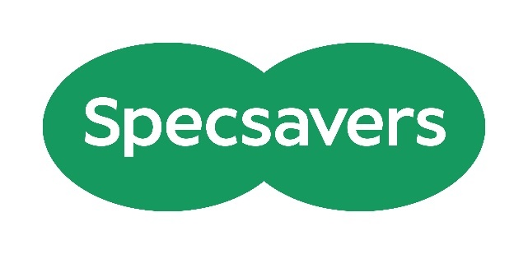

Specsavers invite you to visit their press office during the exhibition. Will Green, PR manager – industry communication, will be on-hand to offer advice on press releases, how to engage local media with your organisation and connecting with your opticians. A professional photographer will also be available to take, for example, profile photos or a team photo. Visit the Specsavers press office to book a time.

### Location of Exhibitors

The exhibition space consists in three different areas: upper lounge, lower lounge, and bar area with a total of eleven stands. Please note the location of each stand is subject to change on the day. Please do not hesitate to ask a member of the Visionary team if you would like an introduction to an exhibitor.

The upper lounge is the first you find when you enter the building after the reception. You can find the entrance on your right. Once you are in the upper lounge the stands from left to right are Optelec, Blind Ambition, Guide Dogs, Charitek, RNIB and ITS VIP.

To access the lower lounge you have a staircase joining upper and lower lounge and also an entrance from the main hall. If you access the lower lounge from the main hall, on your right you find Together.ly, Associated Optical and Charitylog.

The third section is the bar area, to access the bar are there are two entrances by the main hall, one just after the lower lounge and one opposite the restaurant reception. Accessing the bar area by the first entrance, you find the press office on your right, along with Visionary Voices. Torch Trust and Utility Aid on your left by the second entrance.

## Speaker Profiles

We are delighted to share the profiles of our wonderful speakers joining us throughout the event (in the order that they will join the event). We have also included information about our equally wonderful workshop facilitators as part of the workshop summaries – but we are confident you will learn more about them during the sessions.

**Fiona Sandford, CEO, Visionary**

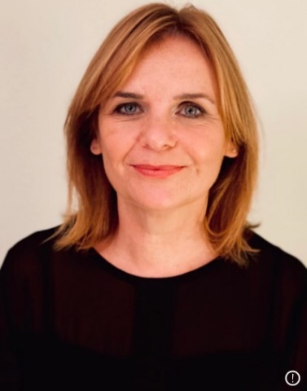

Fiona has been Visionary’s Chief Executive since June 2019 and in that time has seen Visionary innovate and develop in response to our ever-changing environment. Fiona enjoys talking with the wide variety of Visionary members and partners, loves making connections between people and seeing the positive impact that Visionary member organisations have within their local communities.

Previously, Fiona was Chief Executive of Visibility, a local visual impairment charity in Scotland, giving her first-hand experience of the ups and downs that most Visionary member and partner organisations will be familiar with. Before joining Visibility, she was the Scottish Director of Breast Cancer Care. Fiona is also a trustee of two grant-giving trusts – The Corra Foundation and The Blindcraft Trust.

**Matt Stringer, Chief Executive, RNIB**

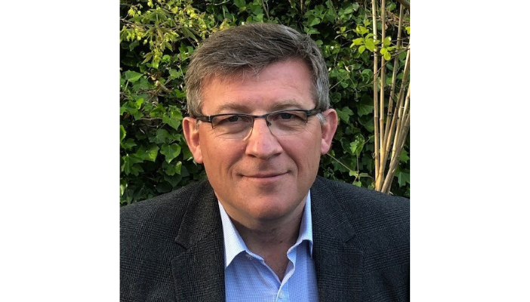

Matt Stringer joined RNIB in May 2019 after thirty years in the retail sector. He held senior leadership roles for well-known high street brands including Marks and Spencer, Carphone Warehouse and Mothercare, as well as spending a period in retail consulting at Accenture.

Since joining RNIB, Matt has led the organisation through a transitional period and the covid pandemic, focusing on access to information and services, challenges of social distancing to fully accessible testing and vaccine processes. The current focus is to drive forward RNIB’s vision of creating a society without barriers for people with sight loss.

**Cathy Low, Director of Partnerships, Thomas Pocklington Trust**

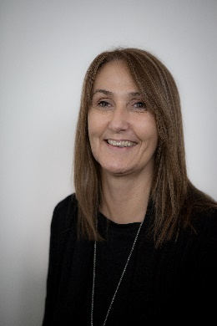

Cathy is Director of Partnerships at TPT, responsible for strategy, collaboration, grants, public affairs/campaigns and communications. Cathy joined the sector in 2016 and is an active member of the VI Charity Sector Partnership’s Lived Experience Leadership workstream. She has lived experience of sight loss and was diagnosed with Stargardts as a teenager.

**Hilary Ingleton, Head of Research and Insight, RNIB**

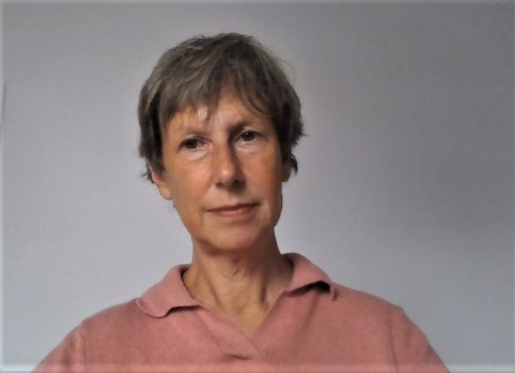

Hilary Ingleton is an experienced market and social researcher and has held roles across a range of public, private and third sector organisations. Since joining RNIB as Head of Research and Insight in 2019, she has collaborated across the sector on projects such as the VI Lives research report and the sector-wide VI Insight Hub.

**Paula McGrath, Deputy CEO, Retina UK**

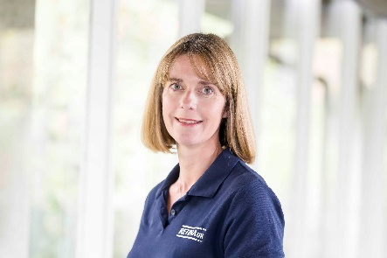

Paula is Deputy CEO at Retina UK. She joined the charity in 2018 following a long career in the health charity sector. Paula is passionate about making an impact for families affected by rare conditions. She uses audience insight to ensure organisational development is designed to meet the needs and aspirations of the communities being served. Paula is also a Trustee of Harry’s Rainbow, a charity that provides support to children bereaved of a parent or sibling.

**Adrian Bell, CEO, Blind Veterans UK**

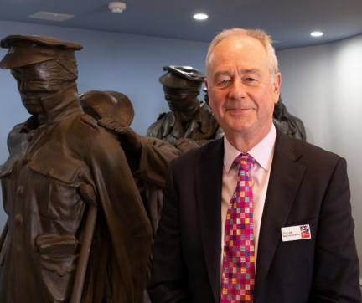

A veteran himself, Adrian served in the Royal Navy for 30 years as a Warfare Officer with the privilege to command three warships. He finished his time as Commander of British Forces in Gibraltar. He decided to leave the Navy in 2010 to work in the charity sector. He was Chief Executive of the Kent, Surrey & Sussex Air Ambulance Trust and joins Blind Veterans UK from his role as the Chief Executive of the Royal Navy & Royal Marines Charity (RNRMC).

**Owen Williams, Director, Wales Council of the Blind and Chair of Visionary**

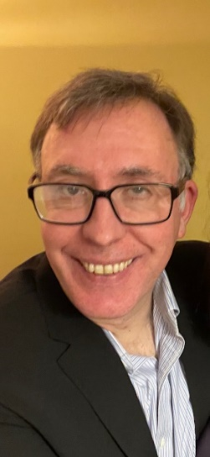

Owen was appointed to the Chair of Visionary in 2019. Owen is the Director of Wales Council of the Blind (WCB) and has over 25 years' experience of working within the sight loss sector in Wales. Owen has Nystagmus and is partially sighted which enables him to bring a unique service-user perspective.

Owen sits on a number of all-Wales groups including Welsh Government's Wales Eye Care Service Joint Committee and is the Chair of the Wales Vision Forum and Low Vision Service Wales Advisory Group. He has a background in access technology and providing specialist assessments and advice including the provision of technical assessments through the Access to Work and Disability Student Allowance (DSA) schemes. Owen has also worked on several projects within health and social care, most recently highlighting the scarcity of Rehabilitation Officer Visual Impairment in Wales.

## VI Charity Sector Partnership Workstream Showcase

During the pandemic eight national sight loss charities collaborated to form a collective response to Covid-19. The Visual Impairment Charity Sector Partnership (VICSP) is the legacy of this collaboration which continues to grow and evolve to provide strategic overview of initiatives that will lead to improving the lives of blind and partially sighted people and those at risk of sight loss across the UK. You can download the latest impact report from the Visionary website via the link below, opens a Word document:

<https://www.visionary.org.uk/knowledge-hub/vi-charity-sector-partnership/>

The founding partners are: Blind Veterans UK, Glaucoma UK, Guide Dogs, Macular Society, Retina UK, RNIB, Thomas Pocklington Trust and Visionary. The partnership is chaired by Matt Stringer, CEO of RNIB and supported by CEOs from all partner organisations, each of whom sponsor the different workstreams.

Join us on **Thursday 28 September 2023** as we welcome representatives from across the partnership to share progress updates and aspirations for the future. This session will focus on this business year’s collaborative activity and demonstrate how local organisations play an important and influential role. Following an overview of each of the workstreams we will have a detailed update on Lived Experience and Talent Development and the VI Insight Hub, both of which have exciting plans for the future. You will hear how Visionary members have influenced each workstream and explore how you can contribute.

Fiona Sandford, CEO of Visionary will introduce the session and set the scene and Matt Stringer CEO of RNIB will share an overview of the partnership. We will be joined by Cathy Low, Director of Partnerships at Thomas Pocklington Trust and Hilary Ingleton, Head of Research and Insight at RNIB who will present workstream updates. This will be followed by a panel session, offering delegates the opportunity to find out more about the workstreams and how this work can benefit blind and partially people in local communities. We are delighted that Paula McGrath, Deputy CEO of Retina UK and Adrian Bell, CEO of Blind Veterans UK will join the panel alongside Matt, Cathy, Hilary and Fiona.

## Visionary Annual Awards Dinner

Welcome to the Fourteenth Visionary Awards.

You are invited to join us from 18:45 for Reception Drinks, sponsored by Associated Optical and House of Townend. We aim to begin seating for dinner at approximately 19:30.

We are looking forward to welcoming you to a relaxing evening, three course dinner and be prepared to test your creative geography skills. Through the evening we will be announcing the winners of this year’s Visionary Awards. Our annual awards strive to recognise and celebrate the impactful services delivered by sight loss charities and the positive difference made to the lives of blind and partially sighted people. As ever, a huge thank you to everyone who took time to share their amazing work and submit a nomination. It is always wonderful to read about your amazing achievements – it makes decision making very hard for the shortlisting panels! Thank you to this year’s award sponsors:

* **Develop and Share Award -** Sponsored by Guide Dogs UK

This awardis an opportunity to celebrate the service developments and applaud the generosity we see every day from the Visionary member and partner organisations.

* **Connect and Collaborate Award -** Sponsored by RNIB

This award is an opportunity for Visionary members and partners to showcase how they have transformed or created a service by collaborating with others to connect with blind and partially sighted people or those at risk of sight loss in new and innovative ways.

* **Children and Young People Award - Sponsored by The Powell Family Foundation**

**This is a new award for 2023 and** an opportunity for Visionary members and partners to showcase how they make a positive difference to the lives of blind and partially sighted children and young people.

* **Community Impact Award -** Sponsored by Specsavers

This award is an opportunity to highlight the amazing work taking place across communities to improve eye health outcomes for people in local communities.

## Workshops

When you arrive at the conference you will receive a reminder of the workshops you have selected and the meeting room each session is taking place in. Please find below a reminder of the amazing selection of workshops, presentation and discussion panels we have on offer during the conference.

Thank you to all our workshop facilitators for giving their time, energy and sharing their expertise and experience at this year’s conference.

### Session One: Wednesday 27 September: 13:45 to 15:00

|  |  |
| --- | --- |
| **Option 1** | **Progressive Sight Loss – Meeting the Needs of Affected Families** |
| **Facilitators** | Chloe Joyner, Founder and CEO, Usher Kids UK  Paula McGrath, Deputy CEO, Retina UK |
| **Summary** | Join Retina UK and Usher Kids UK to explore the type of support needed for families and individuals who have received a diagnoses of progressive sight loss for their child or themselves, and the particular challenges and needs associated with this type of vision loss. |
| **Audience** | All |
| **Geography** | UK wide |
| **Biographies** | **Profile of Choe smiling**  **Chloe Joyner**  Chloe founded Usher Kids UK in response to personal experience of an Usher diagnosis for her child. She draws upon insight from over 200+ families in the Usher Kids UK network to champion services which meet and address the needs of those diagnosed with Usher syndrome. Chloe is passionate about equipping and empowering the next generation of children and families with the tools, resources and connections they need to thrive.  Profile picture of Paula wearing a Retina UK tshirt  **Paula McGrath**  Paula is Deputy CEO at Retina UK. She joined the charity in 2018 following a long career in the health charity sector. Paula is passionate about making an impact for families affected by rare conditions. She uses audience insight to ensure organisational development is designed to meet the needs and aspirations of the communities being served. Paula is also a Trustee of Harry’s Rainbow, a charity that provides support to children bereaved of a parent or sibling. |
| **Sponsor** | Thank you to **Sight Scotland** for sponsoring this workshop.  Sight Scotland Logo |
| **Option 2** | **Collaborative Campaigning: A Panel Discussion** |
| **Facilitators** | Eleanor Briggs, Head of Policy, Public Affairs and Campaigns, Guide Dogs UK (Panel Host)  Scott Jobson, CEO, MySight York  Bernadette Mcintosh, Campaign Officer, Vision Support Barrow and District  Laura Walker, CEO, Visibility Scotland  Owen Williams, Director, Wales Council for the Blind  Sophie Dodgeon, Head of Policy and Public Affairs, RNIB  Mike Bell, Head of Public Affairs and Campaigns, Thomas Pocklington Trust |
| **Summary** | Join us for an interactive discussion aimed at enhancing collaborative campaigning and influencing across the sector. The panel, compromising of Visionary members and partners, will lead discussions on how the sector can benefit from working together to campaign and influence, support each other, identify shared goals and engage with local communities to make a difference to the lives of blind and partially sight people. We will explore recent successes and challenging experiences to develop future aspirations for working together. |
| **Audience** | All |
| **Geography** | UK wide |
| **Biographies** | **Eleanor Briggs (Panel Host)**  Eleanor Briggs joined Guide Dogs this year as Head of Policy, Public Affairs and Campaigns. She has more than twenty years' experience in campaigning, working in the children's sector and disability organisations including Action for Children, the National AIDS Trust and Turning Point. She began her career in the civil service working on equality and diversity policy.  **Scott Jobson**  Scott Jobson is the Chief Executive of MySight York and the Regional Visionary Chair for Yorkshire and Humberside. Formerly a Network Manager for RNIB, Scott has worked in the sight loss sector for 14 years  **Bernadette McIntosh**  Coming from a Banking and Small Business background, I have spent the last 25 years working for national charities - Macmillan Cancer Relief, Marie Curie Cancer Care and most recently for CAFOD – an International Development Agency. I have a broad and extensive experience in leading work at local, regional and national levels working in partnership with local volunteers and communities on issues which affect their lives**.**  **Laura Walker**  Laura Walker is Visibility Scotland’s CEO. She is a qualified rehabilitation practitioner with over 20 years of experience. Laura has extensive knowledge and experience in delivering multi-disciplinary approaches and multi-agency working. Laura has been part of Visibility Scotland’s team for over 16 years and has received awards for innovation and project delivery.  **Owen Williams**  Owen was appointed to the Chair of Visionary in 2019. Owen is the Director of Wales Council of the Blind (WCB) and has over 25 years' experience of working within the sight loss sector in Wales.  Owen sits on a number of all-Wales groups including Welsh Government's Wales Eye Care Service Joint Committee and is the Chair of the Wales Vision Forum and Low Vision Service Wales Advisory Group.  **Sophie Dodgeon**  Sophie Dodgeon has worked in charity campaigning for more than 20 years, including heading up campaigning for international development charity CAFOD, and establishing a policy and public affairs function for Rainbow Trust Children's Charity. Sophie joined RNIB in 2021 and is currently the interim Head of Policy and Public Affairs.  **Mike Bell**  Mike is the Head of Public Affairs and Campaigns at Thomas Pocklington Trust and he has worked in the sight loss sector for 10 years. Previously he has worked in campaigns for a political party and for MPs, MEPS and a Government Minister. He is the Leader of North Somerset Council, a unitary authority in the south west. |
| **Option 3** | **Ch-Ch-Changes or Learning from my Mistakes!!** |
| **Facilitators** | Lauren Williams, CEO, Vision North Somerset  Claire Atkinson, Service Manager, Vision North Somerset |
| **Summary** | Using examples from 18 months of change in a small charity, Lauren will facilitate discussions to support attendees to:   * Strategically analyse the need for change in their charity. * Be bold and persistent with change programmes. * Lead change with a values focus.   Using her experience as a case study, we will be looking at:   * Why we needed to change (and how we knew) linked to situation analysis theory and discussion of reasons for change. * How we went about the changes (what we got right and mistakes) linked to change management theory and values-based leadership.   The session will be interactive with small group discussions throughout for delegates to apply learning to their own situations. |
| **Audience** | Leaders, small and medium sized organisations |
| **Geography** | UK wide |
| **Biographies** | **Lauren smiling**  **Lauren Williams**  Lauren has spent her career in the education and charity sectors with 8+ years in charities working in visual impairment and hearing impairment. She worked across the whole UK with local and national charities. She holds a Masters Degree in Management.  **Claire looking to the side smiling**  **Claire Atkinson**  After a career in customer service, Claire lost her sight in 2016 Claire completed a degree in Social Policy with Criminology. She started work at Vision North Somerset at Peer Support Services Coordinator and was quickly promoted to Service Manager, line managing five people over three different services. |
| **Sponsor** | Thank you to **Specsavers** for sponsoring this workshop.  Specsavers logo |
| **Option 4** | **Recruitment, Respect and Retention – The Keys to Volunteer Engagement** |
| **Facilitator** | Joe Green, Founder, Third Sector Network |
| **Summary** | There are 165,000 charities in the UK, and over 95% of them are classified as ‘small’. The sector is overwhelmingly made up of incredible non-profits who are operating on very limited budgets, often with 2-3 people trying to do the work of 10. It cannot be put more plainly than volunteers are often the single biggest difference between a charity being able to function, or not.  Amid a cost-of-living crisis and spiralling wage inflation, the need for selfless, dedicated and skilled people offering their time and effort for free has never been more essential.  In this presentation, Joe Green from Third Sector Network will highlight the ways charities can understand, appreciate, and engage the volunteers more effectively. How to attract capable people, support and develop them professionally and give them the desire to stay with you and succeed together as a team. Volunteer engagement is quite simply an area that no charity can afford to overlook or underestimate the importance of. |
| **Audience** | All |
| **Geography** | UK wide |
| **Biography** | Joe Green is Senior Consultant at Third Sector Network. He has extensive experience supporting and working with charities throughout the UK in areas from fundraising to non-profit marketing and volunteer engagement. He has worked with charities from start-ups and solo operations to multi-million-pound non-profits in areas as diverse as fighting poverty, the care sector and cancer treatment. He regularly hosts online workshops for Third Sector Network on subjects such as today’s topic.  You can find out more about Third Sector Network via their website – [www.thirdsectornetwork.co.uk](http://www.thirdsectornetwork.co.uk) or find them on social media @mythirdsector. |
| **Sponsor** | Thank you to **Macular Society** for sponsoring this workshop.  Macular Society logo with "Beating Macular Disease" underneath. |
| **Option 5** | **How to Fix the Access to Work Programme** |
| **Facilitators** | Martin O’Kane, Strategic Lead for Employment and Technology, RNIB  Bhadrika Chauhan, Employment Manager, RNIB |
| **Summary** | Delays to the UK Government’s Access to Work (AtW) scheme are holding back many people with sight loss from entering the workplace or carrying out existing roles. Working together, RNIB and Visionary have taken action to influence DWP to address these delays. This session will outline what progress is being made to fix this, what else needs to happen and how you can help with the campaign.  We invite you to attend to find out how you can help us to campaign for the improvements in the AtW system that are needed.  We’ll also allocate some time at the session to discuss the most common areas of support that people with sight loss are asking AtW to assist with and how best to ensure that the correct support is provided. |
| **Audience** | All |
| **Geography** | UK wide |
| **Biography** | **Martin smiling in front of a window**  **Martin O’Kane**  Martin leads RNIB’s Employment and Technology Services and has worked in the field of sight loss and employment for many years. He is passionate about removing barriers for people with sight loss to find and retain work. |
| **Option 6** | **Getting Involved with the UK National Eye Health and Hearing Study (UKNEHS) - Local, Regional, and National Implications of Having Population and Care Home Data on Sensory Health and Utilisation of Health and Social Care Services for the First Time.** |
| **Facilitators** | Professor Rupert Bourne, Consultant Ophthalmic Surgeon and Professor of Ophthalmology, Cambridge University Hospital  Michael Bowen, Director of Research and Knowledge, The College of Optometrists |
| **Summary** | The workshop will introduce delegates to the progress of the UKNEHS, its local and international reach, and how this project bridges health and social care, and policy implications. The UKNEHS aims to discuss with delegates the key indicators and barriers to uptake of sensory care services and offer those participating an opportunity to join this national project. |
| **Audience** | All |
| **Geography** | UK wide |
| **Biographies** | Professor Rupert Bourne wearing a white shirt, blue tie and blazer.  **Professor Rupert Bourne**  Chief Investigator of UKNEHS & National Specialty Lead for Ophthalmology for the NIHR Clinical Research Network- lead for the international ophthalmology epidemiology reference group that provides the WHO data on vision impairment and co-designer of several similar national studies overseas.  **Michael smiling in front of a statue**  **Michael Bowen**  Michael Bowen is the Director of Knowledge and Research at the College of Optometrists, where he is responsible for the strategic development of the College's Research activities, and Knowledge resources. Michael has led various research projects within the sector, including PrOVIDe - which gathered data on the prevalence of visual impairment among people living with dementia in England. |

### Session Two: Wednesday 27 September: 15:30 to 16:45

|  |  |
| --- | --- |
| **Option 1** | **Redefining Possibilities: Unleashing the Power of AI** |
| **Facilitator** | Simon Moxon, Founder and CEO, Together.ly |
| **Summary** | An inspiring journey into the transformative power of artificial intelligence (AI). This workshop, curated for Visionary members and partners, will demystify AI, highlighting its practical uses in everyday operations, and exploring its potential to revolutionise the lives of those we serve. From operational enhancements to life-changing adaptations for blind and partially sighted people, you'll discover how AI is reshaping the way we help.  Led by Simon Moxon, founder of Together.ly, you'll learn, be inspired, and leave equipped with the knowledge to navigate the evolving landscape of AI. |
| **Audience** | All |
| **Geography** | UK wide |
| **Biography** | **Profile image of Simon against a plain background**  **Simon Moxon**  Simon Moxon is founder and CEO at Together.ly. He is a life-long technologist, a multiple startup founder, entrepreneur and charity trustee. Today Simon is working on two of the most pressing societal challenges of our time - the economic burden of an ageing population and the endemic issue of loneliness and isolation - and building the technology that can help solve them. |
| **Sponsor** | Thank you to **Together.ly** for sponsoring and hosting this workshop.  Together.ly logo |
| **Option 2** | **Art Beyond Vision: The Transformative Effect of Running an Art Project for the First Time** |
| **Facilitators** | Hayley Grocock, CEO, Wakefield District Sight Aid  Ruth Fones, Independent Artist and Teacher |
| **Summary** | In this workshop, CEO of Wakefield District Sight Aid Hayley will talk about how emerging from Covid has made her braver as a leader, and how this has led to the delivery of their first ever fully accessible art project with local artist Ruth Fones. Through the power of collaboration and co-design with people with lived experience of sight loss, the concept for Art Beyond Vision was born, and some funding for a pilot project through Wakefield Council’s Culture Grants, was secured.  We expect our service users to adapt and try new things all the time, but Hayley and Ruth will share how Art Beyond Vision challenged them both to do things differently and for the first time. Both will share what they have given and what they have gained from the project. They will also talk about the challenges of keeping accessibility at the heart of everything they do, bearing in mind a wide range of previous creative experience, plus a huge spectrum of sight loss.  By the end of the workshop, you will feel inspired to create your own art project and have gained some great advice on how to apply for funding to get started. |
| **Audience** | All |
| **Geography** | UK wide |
| **Biographies** | Hayley with Jim, who used Wakefield DSA services  **Hayley Grocock**  Hayley has a very diverse background, having worked within the commercial sector, the social enterprise movement, and with charities.  Since September 2017, Hayley has been Chief Executive Officer of Wakefield District Sight Aid, a charity established in 1869 which supports people living with sight loss, their families, carers, and sight care professionals across the Wakefield district in West Yorkshire. Having never worked in the sight loss sector before, Hayley will tell anyone who will listen that it’s the best job she’s ever had and thrives on the many challenges that come with running a small organisation.  Ruth assisting a gentleman with art  **Ruth Fones**  Ruth Fones is an artist and teacher based in West Yorkshire, UK. Through her extensive work as an educator, Ruth Fones has continuously observed the subtle variations in our individual perception of colour, light, form and perspective. Her own diagnosis of a common age-related sight change triggered a moment of significant reflection for the artist, and uncovered a wider fascination with the differences in our vision**.** |
| **Option 3** | **Developing Sustainable Children and Young People’s Services – A Panel Discussion** |
| **Facilitators** | Colin Whitbourn, The Powell Family Foundation (Panel Host)  Claire Park, Chief Executive, Sight Advice South Lakes  Nick Schofield, Chief Executive, VICTA  Mark Sanderson, Parent & Assistant Director Children Young People and Families, Guide Dogs |
| **Summary** | This panel session will focus on developing sustainable children and young people’s services. Panel members from local and national organisations will be joined by a parent to share their experiences of:   * developing new services, * evidencing the needs specialist services, * working in partnership to create opportunities for children and young people, * working with statutory organisations and * how a Children and Young People’s service can be embedded into an existing organisation.   We are honoured to be joined by a parent with lived experience, who will share their thoughts on how focussed services can make a difference to children, young people and families. |
| **Audience** | All |
| **Geography** | UK wide |
| **Biographies** | **Colin Whitbourne (Panel Host)**  Colin has worked for vision impairment charities for over 20 years including Action for Blind People and RNIB. He is now Executive Director at The Powell Family Foundation.  **Claire Park**  Claire leads a team of passionate and highly motivated individuals working together to make a real difference to the lives of blind and partially sighted people. Claire has held senior-level positions in the voluntary and community sector for over 20 years, previously working at national and local level for Age UK and Alzheimer’s Society. In 2018, Claire was selected by Garfield Weston for the Pilotlight Leadership Programme. Following this programme Claire gives support to other small sized charities particularly around governance.  **Mark Sanderson**  Mark has lived experience of vision impairment as a parent, partner and himself. He qualified in accountancy and HR. Following an early private sector career has spent the last 30 years working in the disability and sight loss sectors, the majority in large disability charities such as RNIB, Mencap, Leonard Cheshire, and Guide Dogs, in senior operational roles. Now Assistant Director Children’s Services with Guide Dogs, he has parental experience of supporting a child with multiple disability/health needs and navigating the education, health and social care system for support. Mark Chairs the Children and Young People with a Vision Impairment Network, which brings together key representatives of organisations supporting children with sight loss.  **Nick Schofield**  Nick started his working life in the city followed by a five-year posting in Singapore. Before returning to the UK, he took a year-long sabbatical in India where he worked for His Holiness the Dalai Lama and the Tibetan Government-in-Exile. Nick has a Masters in Communications Management and built a communications and messaging framework for use within the Tibetan community. Nick became a Trustee of VICTA in 2010 bringing his marketing and communications skills to the board. He became a member of the VICTA staff team in 2017 as Director of Strategy, Communications and Fundraising. |
| **Sponsor** | Thank you to **The Powell Family Foundation** for supporting us to create this panel session.  The Powell Family Foundation Logo |
| **Option 4** | **Fit for the Future? Rehabilitation and Habilitation** |
| **Facilitator** | Laura Walker, CEO, Visibility Scotland |
| **Summary** | Using the model of how rehab is evolving in Scotland, Laura Walker, CEO of Visibility Scotland will discuss the role of rehabilitation and habilitation, how that is now and how it could be in the future.  Laura will talk about the current challenges being experienced by the profession and how these might be addressed. As a qualified rehab practitioner, Laura brings her own knowledge and experience to this discussion. She will seek views from workshop participants that can be fed back to Visionary in order to influence our regular Visionary Rehab Forum and also be highlighted within the VI Charity Sector Partnership conversations.  Workshop participants will learn more about the Scottish Visual Services Steering Group and what the group is setting out to do. Laura will discuss how this model can influence a UK wide response and how we can collectively make things better for people who need rehab and hab services. |
| **Audience** | Practitioners and Leaders |
| **Geography** | UK wide |
| **Biography** | Laura smiling, wearing a black blouse and yellow blazer.  **Laura Walker**  Laura Walker is Visibility Scotland’s CEO. She is a qualified rehabilitation practitioner with over 20 years of experience. Laura has specialised in and pioneered neuro-rehabilitation services. Laura had previously established her own business - Visual Rehabilitation Scotland - which enabled her to deliver person-centred, holistic services to people across Scotland. Laura is passionate about accessibility and service equality: the right service at the right time!  Laura has extensive knowledge and experience in delivering multi-disciplinary approaches and multi-agency working. Laura has been part of Visibility Scotland’s team for over 16 years and has received awards for innovation and project delivery. |
| **Sponsor** | Thank you to **Blind Veterans UK** for sponsoring this workshop.  Blind Veterans logo - Rebuilding lives after sight loss. |
| **Option 5** | **Working Together to Transform Domestic Violence Refuges into Sight-Friendly Spaces.** |
| **Facilitators** | Becky Green, Engagement Manager, Beacon Centre for the Blind  Dani Walker, Independent Domestic Violence Advisor, Churches Housing Association of Dudley & District (CHADD) |
| **Summary** | After the successful Vision Foundation partnership project between Beacon Centre and CHADD, we have explored how VI people could be more vulnerable to domestic abuse and we have listened to people’s experiences of accessible services. We have shared training and skills, devised joint training and worked locally to make refuge spaces more accessible.  This workshop will be the launch of our new toolkit. Our toolkit for accessible refuge spaces has been designed to share across the UK, linking VI support services to their local domestic abuse services, helping to make the journey smoother for VI people accessing refuge accommodation.  This workshop will help delegates explore the link between sight loss and domestic abuse and introduce new partnership working. |
| **Audience** | All |
| **Geography** | UK wide |
| **Biographies** | **Becky Green**  Becky is Beacon’s Engagement and Lifestyle Manager and has 9 years’ experience working with VI people. Becky’s role involves leading the face to face activities and support services for VI people, Talking News Service, Befriending service and Sight Loss Advice service helping VI people to gain more independence and confidence to live healthy, happy lives.  **Dani Walker**  Dani is a qualified Independent Domestic Violence Advisor within the Outreach Team at CHADD. Dani has 10 years’ experience working in both refuge and in the community. She leads on a specialist service supporting residents of Dudley with a disability, mental health and supporting those from minoritised communities that have been or are at risk of domestic abuse. |
| **Sponsor** | Thank you to **Specsavers** for sponsoring this workshop.  Specsavers logo  Specsavers logo |
| **Option 6** | **Travel Matters: How Accessing Public Transport Impacts on the Lives of Blind and Partiality Sighted People** |
| **Facilitators** | Ella Burton, Senior Researcher, Revealing Reality  Maeve Garner, Associate Director, Revealing Reality |
| **Summary** | This workshop will share an outline of Visionary’s exciting new research project which is working with Ella Burton and Maeve Garner, at the research agency Revealing Reality, to find out more about how access to public transport impacts on the lives of blind and partially sighted people.  Our ambition for this year long project is to gather information from participating organisations and learn alongside them as they understand more about the impact of public transport and develop ways of influencing local providers to improve the situation. We would be interested to know what the situation is within your area and how you think it could be different.  Attending this session will help us all to understand more about the impact that public transport has on the lives of blind and partially sighted people, and to identify where improvements could be made to the transport system. By supporting us with this project, you will be directly helping to improve the experiences of blind and partially sighted people when using public transport in your area and beyond. |
| **Audience** | All |
| **Geography** | UK wide |
| **Biographies** | Ella Burton smiling.  **Ella Burton**  Ella is a senior researcher at Revealing Reality and has been managing this piece of work in collaboration with Visionary. She has plentiful experience working directly with individuals living and impacted by various health conditions to capture their voices through qualitative research methods.  Maeve Garner smiling.  **Maeve Garner**  Maeve is an associate director at Revealing Reality and is one of the team’s most experienced researchers. This has been drawn from a wealth of experience conducting research projects for numerous charities. She has previously carried out research with individuals representing a range of experiences, including people with disabilities and those suffering with long term illnesses. |
| **Sponsor** | Thank you to **Motability Foundation** for supporting us to host this workshop.  Motability Foundation logo - Making all journeys accessible. |

### Session Three: Thursday 28 September: 10:30 to 11:45

|  |  |
| --- | --- |
| **Option 1** | **Social-Communication, Language and Interaction in Children with Severe and Profound Visual Impairment.** |
| **Facilitator** | Elena Sakkalou, Senior Lecturer in Psychology, Anglia Ruskin University |
| **Summary** | Children with congenital profound or severe visual impairment are at high risk of social-communication difficulties, including difficulties with pragmatic language and interaction (Tadic et al., 2010). These findings have implications for the high prevalence of Autism Spectrum Disorder (ASD) in VI reported in the literature, and which is estimated to be as high as ~30% (Do et al., 2017). However, any child with severe-profound VI is likely to have significant delays in cognitive, language, and social development and it has not been known whether an additional social-communication risk can be successfully differentiated under three years and whether a child with social-communication risk early on can continue to present with these difficulties during childhood.  Elena will present data from the Optimum project (Dale et al., 2017) which examined cognition, language and social-communication in toddlers with VI and longitudinal associations with language and social-communication from the DAiSY project (Dale et al., in preparation) when children were seen again when they were 4-7 years of age. The results are discussed in terms of clinical and educational implications. |
| **Audience** | All |
| **Geography** | UK wide |
| **Biography** | Head and shoulders image of Elena smiling and wearing a green floral blouse.  **Elena Sakkalou**  Elena Sakkalou is a Senior Lecturer in Psychology at the School of Psychology and Sports Science, Anglia Ruskin University and Honorary Senior Research Associate at the UCL Great Ormond Street Institute of Child Health. Elena's research focuses on typical development and neurodevelopmental conditions, and the effect that neurodisability has on cognitive and socio-communicative development. She has been researching the development of children with severe and profound VI for the past 12 years. Elena is very much interested in understanding how developmental trajectories and outcomes can be affected by the interplay between biological, psychological, and sociocultural factors. |
| **Sponsor** | Thank you to **Guide Dogs UK** for sponsoring this workshop.  Guide Dogs logo |
| **Option 2** | **The Power of Sport – A Panel Discussion** |
| **Facilitators** | Martin Symcox, Head of Leisure and Sport, Thomas Pocklington Trust  Alice Holloway, RNIB Lead, See Sport Differently  Kelly Barton, Engagement Manager, Thomas Pocklington Trust  Marc Gulwell, Sight Loss Adviser Team Manager, Sight Support West of England  Gareth Davies, Stakeholder Engagement Manager – Accessibility, RNIB  Ian Isham, Head of Sport Development, British Blind Sport |
| **Summary** | In August, The International Blind Sports Federation (IBSA) World Games are coming to Birmingham. The panel discussion will highlight the connection between physical activity and good mental health for blind and partially sighted people.  The discussions will highlight the necessity of working collaboratively to provide support and opportunity to help blind and partially sighted people start to become a little more active. The panel will discuss the challenges with access to local provision and showcase what local sight loss organisations could do to support equitable access to facilities and activities.  We will hear how people and organisations have been able to remove barriers and create opportunities that allow blind and partially sighted people to remain active and understand how to boost their mental health.  This panel session will provide the opportunity to explore the impact of sport on all aspects of our lives. We will share ideas and opportunities to engage local people in sport and to try new physical activities. There will be an opportunity for delegates to share their own work and experiences as we discuss how we can make a difference through sport. |
| **Audience** | Leaders, Project/Service Managers, Practitioners |
| **Geography** | UK wide |
| **Biographies** | **Martin Symcox (Panel Host)**  Martin is Head of Sport and Leisure Development at Thomas Pocklington Trust, joining the team in 2022 from Metro Blind Sport. Martin is passionate about improving the accessibility of opportunities for blind and partially sighted people to participate and engage in sport and leisure to improve physical and mental health and well-being.  **Alice Holloway**  Alice has spent 12 years working in the sports industry at some of the world’s biggest commercial brands including London 2012, Manchester United and Sky Sports. In 2017, she brought her experience of leading large-scale projects and marketing campaigns into the non-profit and third sector, with a focus on concept development and mass participation. She is currently leading a new strategic area of work within disability sport for national sight loss charity RNIB, directing a £1m Sport England funded initiative tackling inequalities for people with sight loss and enabling more people to enjoy the benefits of sport and activity.  **Kelly Barton**  Kelly is Engagement Manager (North West) for Thomas Pocklington Trust and oversees the Lancashire, Merseyside and Greater Manchester Sight loss Councils. Kelly has always been blind and has a good understanding of the issues affecting people who have sight loss. Outside of work, Kelly has a real interest in sports, is a keen runner and cyclist and recently joined a blind baseball team. Kelly is a huge advocate of physical activity and the massive benefits this can have to mental health and wellbeing.  **Marc Gulwell**  Marc is the Advice Team Manager for Sight Support West of England and founder of The Gloucestershire Growlers VI Cricket Club, The Insight Gloucestershire Goalball Team, award winning cricketer, Goalball medallist, endurance cyclist medallist, footballer, rower, skittles and eight ball pool players. When Marc lost his central vision very quickly, he found himself on a field in Cheltenham with a group of fellow blind and visually impaired folk trying out cricket for the first time. From that moment on, his life had changed forever. The power of sport and physical activity can never be underestimated.  **Gareth Davies**  Gareth Davies from Wales is a visually impaired rugby player and a founding member of Cardiff Rugby’s VI Team. Gareth has been lucky enough to play VI Rugby around the world including Japan and is currently working with the club to develop a Youth Team to ensure young people living with Sight Loss in Wales and the South West of England have the opportunity to play the game.  **Ian Isham**  Ian has worked in the sports industry for the past 13 years, joining British Blind Sport in January as the Head of Sport Development. Ian’s role is to lead and co-ordinate efforts to increase sports participation and help support National Governing Bodies, clubs and partners to develop their workforce and become more inclusive. He has been heavily involved in the IBSA World Games held in Birmingham this summer and leading the sports development strand of the game's legacy group. |
| **Sponsor** | Thank you to **See Sport Differently** for sponsoring this panel discussion.  **See Sport Differently logo** |
| **Option 3** | **10 Things I’ve Learnt as a Fundraiser Turned Grant Assessor** |
| **Facilitator** | Vic Hancock Fell, Founder, Fair Collective |
| **Summary** | Vic has been a fundraiser for more than 15 years. Last year Vic was on the other side of the proposal, as an assessor. During this time, she learnt a lot, and, in this session, Vic will share what she will now be doing differently in her fundraising and grant applications as a result.  Vic will talk you through 10 things she’s learnt as a fundraiser turned grant assessor and there will be time for peer learning, troubleshooting and Q&A. You’ll leave the session with a boost of confidence and some new ideas to take into your fundraising and grant writing.  Attendees are encouraged to bring their organisation’s Case for Support document or a recent grant application, as there will be an opportunity to reflect and develop this during the workshop. |
| **Audience** | Anyone responsible for fundraising or supporting fundraising. This session will be appropriate for organisations of all sizes but may be of particular interest to small and medium sized organisations. |
| **Geography** | UK wide |
| **Biography** | Vic Hancock-Fell smiling and leaning against a shiny wall  **Vic Hancock-Fell**  Vic is the Founder of Fair Collective, a social enterprise that helps socially purposed organisations do more good stuff with affordable freelance support. She has almost 15 years’ experience working within the small charity sector and is passionate about helping organisations of all shapes and sizes access the appropriate and affordable support they need and deserve. |
| **Sponsor** | Thank you to **Macular Society** for sponsoring this workshop.  Macular Society logo with "Beating Macular Disease" underneath. |
| **Option 4** | **Inclusive Service Design and Delivery: Reaching Everyone Who Needs Us.** |
| **Facilitator** | Debbani Ghosh, CEO, Association of Blind Asians |
| **Summary** | This workshop will explore examples of how the Association of Blind Asians shape the way they design and deliver services. Debbani will share innovative ways of reaching local communities and participants will come away with tangible actions they can take to ensure their services are relevant, accessible, and inclusive to all that need them.  Join Debbani Ghosh, CEO of Association of Blind Asians Leeds, who will share their work and facilitate discussion on designing inclusive services. |
| **Audience** | All |
| **Geography** | UK wide |
| **Sponsor** | Thank you to **Fight for Sight/Vision Foundation** for sponsoring this workshop.  The Fight for Sight and Vision Foundation logos joined together like a jigsaw puzzle piece |
| **Option 5** | **The Merger Rollercoaster** |
| **Facilitators** | Sarah French, CEO, Vision and Hearing Support  Keith Valentine, CEO, Fight for Sight/Vision Foundation |
| **Summary** | This workshop is an opportunity to explore what lies behind the practicalities and legal requirements of mergers. The workshop will be hosted by Keith Valentine from Fight for Sight and Vision Foundation and Sarah French from Vision and Hearing Support, who both have recent experience within their own organisations of mergers. They will explore the drivers which led to a decision to merge, the opportunities it has and will present for their respective organisations and their beneficiaries. They will also share the impact on them as leaders and their teams throughout the process and beyond.  The workshop will focus on the drivers for change and the ups and downs of the journey, rather than the practicalities. If you want to learn more, come along – it is a rollercoaster. |
| **Audience** | CEO, Leaders and Trustees |
| **Geography** | UK wide |
| **Biographies** | Sarah French smiling  **Sarah French**  Sarah has worked in the voluntary and community sector for 25 years, joining the sight loss sector in 2019 as CEO of Vision & Hearing Support. She has a genuine interest in equality and creating a fair society as well as strong environmental and ethical values which is reflected in her career.  With a particular interest in charity governance and collaborations, Sarah has led several cross-sector partnerships, including a community-led housing renewal scheme and, more recently, three successful partnership bids valued at almost £1m over five years. Sarah is an active representative of the Voluntary Sector at numerous national, regional and local networks including Visionary UK North East of England representative, the NENC Integrated Care Board VCS representative for Ageing Well, and the South Tyneside Living Well Alliance.  This enthusiasm for bringing people together extends to Sarah’s personal life, where she is usually organising a social event, day trip or family gathering!  **Keith Valentine sitting on a wall with his guide dog at his feet.**  **Keith Valentine**  Keith Valentine is the Chief Executive of Fight for Sight and Vision Foundation. With a track record of over 25 years, Keith has previously been Director of External Affairs at RNIB, Chief Executive of Vision UK and has been a Trustee of Retina UK and Action for Blind People. Keith is a strategic leader and a known force within government and industry when it comes to highlighting key issues affecting people with eye conditions.  Keith’s passion and drive come, not least, from his experience of living with retinitis pigmentosa, a hereditary condition causing him to lose his sight at the age of 36. |
| **Sponsor** | Thank you to **Fight for Sight/Vision Foundation** for sponsoring and hosting this workshop.  The Fight for Sight and Vision Foundation logos joined together like a jigsaw puzzle piece |

### Session Four: Thursday 28 September: 12:15 to 13:30

|  |  |
| --- | --- |
| **Option 1** | **Chairs, Trustees and CEOs – Finding the Balance** |
| **Facilitator** | Brian Cavanagh, Founder, Brian Cavanagh Consulting |
| **Summary** | This workshop will build on information gathered during two Visionary sessions, led by Brian Cavanagh in June, speaking separately with trustees and CEO’s.  The workshop will bring trustees and CEO’s together and consider a range of issues including:   * Establishing clear relationships between paid members of staff and trustees. * Developing an effective working relationship between the chair and the CEO. * How to recognise what is operational and what is governance. * How trustees can feel confident things are being managed well without managing! * How CEO’s can engage effectively with a board of trustees. * How to share uncomfortable truths. |
| **Audience** | CEO’s, Leaders and Trustees. |
| **Geography** | UK wide |
| **Biography** | a head and shoulders image of Brian Cavanagh  **Brian Cavanagh**  Brian Cavanagh is the author of Governing with Purpose and an expert on board governance. He acts as a trusted adviser to Chairs and CEOs and draws on his 30 years experience of boards to support organisations and trustees to develop and strength their governance. Brian is currently a trustee on Foscadh Housing Association. |
| **Option 2** | **Service Delivery and Support for Families of Children and Young People with Vision Impairment and Additional Needs.** |
| **Facilitator** | Laura Hughes, CEO, MoorVision |
| **Summary** | 45% of children with Vision Impairment have other disabilities. MoorVision has had 15 years’ experience in delivering a fully accessible service to all children and young people registered with us regardless of their additional needs. We ensure that every child has the opportunities they need to achieve their full potential by offering support in all areas of their education, sport and leisure, wellbeing, peer support, home and social life.  MoorVision will be covering best practice in including children with VI and additional needs in service delivery and offering an interactive workshop on how this can be achieved. Delegates will gain both an insight into the wide variety of additional needs presenting and practical ideas to inform future delivery. |
| **Audience** | All colleagues from organisations delivering services for Children and Young People with VI and additional needs. |
| **Geography** | UK wide |
| **Biography** | Laura Hughes smiling  **Laura Hughes**  Laura Hughes is the founder and CEO of MoorVision, a local society providing support to families of children and young people with vision impairment, including those with other additional needs, across Devon and Cornwall. |
| **Option 3** | **Sensory Services – A Panel Discussion** |
| **Facilitators** | Philippa Simkiss, Philippa Simkiss Consulting (Panel Host)  Lowri Bartrum, CEO, Vision Support  Clare Burgess, CEO, Sight for Surrey  Graham Findlay, CEO, North East Sensory Services |
| **Summary** | This panel session will share experiences and knowledge of developing and delivering joint sensory services. Panel members from England, Wales and Scotland will discuss highs and lows, drivers for change, practicalities, funding and what difference it has made to people. |
| **Audience** | All |
| **Geography** | UK wide |
| **Biographies** | **Philippa Simkiss (Panel Host)**  Philippa Simkiss loves working with Visionary and supporting members who have such a massive impact for blind and partially sighted people and those at risk of sight loss. She has led operations, policy and fundraising departments for RNIB and supported Blind Veterans UK, Sense and Leonard Cheshire with strategic development. She now leads industry engagement for Specsavers, raising awareness of the vital role community opticians play in preventing avoidable sight loss.  **Lowri Bartrum**  Lowri has worked in the third sector her whole career and whilst new to the world of VI, she is learning fast from people who receive support from Vision Support and her colleagues who have visual impairments. Lowri has over 15 years experience of managing Local Authority commissioned contracts and the sensory services Vision Support provide are through such contracts.  **Clare Burgess**  Clare has been CEO for Sensory Services by Sight for Surrey for the last 9 months, and previously led a pan-disability Disabled People’s Organisation. Prior to this, Clare had a broad range of third sector, and shared (Integrated Care System) roles in Mental Health, and prior to that worked for Guide Dogs for the Blind as a Service Delivery Manager. Clare has lived experience of vision impairment.  **Graham Findlay**  Graham originally trained as a welder for a boat builders in Cullen, until his sight loss made this impossible. Graham re-trained as a social worker, and has since developed his experience working in the voluntary sector. Appointed to Chief Executive in 2009, Graham managed the charity's dramatic transformation into what is now North East Sensory Services (NESS). Graham is accountable for all NESS' operations and committed to supporting people with a sensory loss to live as independently as they can. |
| **Option 4** | **Eye Care Support Pathway** |
| **Facilitators** | Phil Ambler, England Country Director, RNIB  Pete Hoey, Pathways Lead, Visionary |
| **Summary** | A presentation about the new Eye Care Support Pathway and how Visionary and RNIB are working together to support local organisations to influence Integrated Care Systems in adopting it. |
| **Audience** | All |
| **Geography** | England |
| **Biographies** | Phil Ambler wearing a white shirt, burgundy tie and dark blazer.  **Phil Ambler**  As England Country Director for RNIB, Phil brings over a decade’s worth of experience of influencing change in the eye health and sight loss sector having worked closely with partners from across health, social care and the third sector to seek improvements in eye care provision and to enable people who are blind or partially sighted to live independently in an equal society.  Pete Hoey headshot  **Pete Hoey**  Pete has worked in a variety of settings, and in the last eight years has worked in several sight loss sector charities (Accrington, Sightline, and Halifax), contributing to their development and improved services for people with sight loss. Prior to that, he worked at Kirklees Council, co-productively developing and commissioning many innovative services in the substance misuse field, and housing for local older people. He is qualified as a social worker, has lived experience of sight loss, and an MA in Social Diversity, and was the first in his family to access university education. |
| **Option 5** | **Making an Impact: How Evaluation can be used to Evidence the Impact of Services and Influence Future Development.** |
| **Summary** | This workshop will introduce delegates to the importance of robust evaluation and the potential benefits it can bring within your organisation. There will be a chance to apply some elements of a specific method to your own organisations and discuss how it could help develop your impact and evaluation work.  Attendees are encouraged to bring along an example of your current evaluation framework as there may be an opportunity for peer support and discussion. |
| **Audience** | All - Mainly those who are responsible for impact and evaluation, but anyone who is interested in how it can benefit your organisation. |
| **Geography** | UK wide |

## Quick Guide to using Navilens

First steps:

1. Install the free NaviLens app on Google Play or App Store. The application can be downloaded from these links:

* App Store: <https://apps.apple.com/us/app/navilens/id1273704914>
* Google Play: <https://play.google.com/store/apps/details?id=com.neosistec.NaviLens>

1. Run the application, accept the permissions and terms of use and privacy policy.
2. Start using the application by orienting the camera towards the environment until you hear a "click" sound that will indicate that a marker has been detected.

In the initial screen of NaviLens, you will find a simple interface composed of a central screen where the codes detected will appear and a bottom menu with buttons. You can interact with the codes you detect by selecting them with a double tap using your screen reader. NaviLens codes or markers are detected with their reading through the mobile camera.

Therefore, the camera must be oriented towards the outside trying to make its orientation the most appropriate depending on where the codes are placed (walls, floor, height, etc. ...)

Each time the mobile device's camera detects a code, the device will make a "click" sound that will inform the user that there is a NaviLens code signalling a component.

The reading of the code will begin immediately, NaviLens will announce the information contained in the marker (the room number or name).

You can stop the reading by making a "Shake" gesture. The "Shake" gesture is executed by performing a wrist turn. If the phone is in an upright position, put the device horizontally (landscaped) and return it to an upright position.

When NaviLens finishes reading the information contained in the code, it will begin to play sounds to indicate the location of the signalled element. Information in vocal instructions can be obtained by activating them in the configuration (Settings – Location Mode – Voice Instructions) and it will begin to say vocal instructions (right, left, front, back, up, etc.) that will help us reach the signalled element.

After detecting a code, while you do not make the shake gesture or click on the tag to obtain the information, the app will also perform this locution, and it will indicate the distance to the element and guidance instructions to get to it. When the camera detects more than one marker, the app will indicate the detection of each one by a "click" and when it reads each one it will indicate 1 of X, 2 of X, etc.

Of all the codes, the one that is most central to the device's camera will be read first.

If the mobile camera detects a "magnet" code such as at a bus stop, this code will be spatially positioned by the system and the 360 Vision mode will automatically open, setting the stop code as a destination and, as if it were a magnet, guiding towards it by sounds, vocal instructions and haptic vibrations. 360 mode will continue to guide you to the location of the code even if the mobile device camera loses it from sight.

You can find out more information about how NaviLens works in this YouTube video: <https://www.youtube.com/watch?v=aemZ5ed4gD8>

## Emergency Evacuation Routes

**A step-by-step guide to navigating Aston Conference Centre and instruction on emergency exits.**

**Entrance and reception area**

* As you stand outside the Aston Conference Centre facing the main entrance, behind you, to the right and left are grass banks with no steps. Directly behind you is a grass verge that raises slightly with a step up.
* To enter the building from the main entrance there are three options. Facing the main entrance to the left is an automatic rotating door which turns anticlockwise. The door starts to rotate on approach and can be manually pushed if required. In the centre there is a manual opening door and to the right is an automatic door, which opens on approach.
* Entering through the automatic door on your right there is a slight lip on the floor in line with the frame and there is a non-slip matt on entering. There are several more non-slip mats as you move through the entrance around the door area.
* Once inside the building there is a seating area in front of you slightly to the right. Turn left then a right turn to approach the reception desk, which has a lowered accessible countertop to the left-hand side.

**Conference registration area**

* Walking past the reception desk with it on your right the floor starts a gentle slope down toward the restaurant and toilets at the end of the corridor. Along the corridor to the left is a ceiling to waist height glass window.
* Continuing down the corridor after the first slope there is a levelled-out section and to the right of this is the conference registration area. The conference registration consists of two long rectangle tables at waist height.

**Lounge, bar and emergency exit**

* The floor then continues on a descending slope for the second time with a hand rail to the right at waist height.
* As you reach the second levelled out part of the floor to the right is the entrance to the lounge. This is a wide high archway opening.
* As you continue down the corridor the floor declines again for a third slope with a hand rail to the right at waist height. Once you reach the flat levelled out section to the right is the wide high arch opening for the bar. Directly opposite the bar is the exit to the outside courtyard. There is a lip at the door, and it opens out onto a flat level then about 4ft ahead there are 2 steps up onto another level. This door would be used as an emergency exit.

**Restaurant, toilets, lift and stairs**

* Continuing further down the corridor to the left has ceiling to waist hight windows and the floor remains flat from here. The floor changes surface from stone to wood with a smoother texture. Once the surface changes you are approaching the restaurant and toilets.
* At the end of the corridor, you turn right to the toilets and stairwell, the lift is on right approx. 20ft before the end of the corridor. You then turn left entering a narrower corridor which bends right. You will find the female toilets to your left, the male toilets straight ahead and on your right find the accessible toilet's’ and baby changing facilities.
* To access the stairwell and the emergency exit turn right at the end of the main corridor. The exit is straight ahead of you and the stairs right-hand side as you go through the first door.

**Conference rooms, courtyard**

* Turning left at the end of the main corridor or walking straight ahead from the toilet area is the entrance to the restaurant. There is a straight walk through the centre of the restaurant towards Conference Room 1. As you walk through the restaurant there are double doors on your left leading to the outside courtyard. The floor continues to be wood, and the noise levels increase.
* As you approach the conference room area the floor surface changes from wood to carpet. As this happens you turn left to enter a corridor. Along this corridor on the right-hand side there are three sets of double doors about 3 metres apart. These doors open outward. These are the doors to conference room 1.
* Continuing past the conference room 3, which is on the left, there are toilets, female, male and accessible on your left and on the right is another door to conference room 1. This enters conference room 1 on the left hand side when facing the front of the room.
* From any exit from conference room 1 one turn left to head back toward the restaurant.

**First floor conference rooms**

* When exiting the restaurant to the main corridor there is a lift to the left which takes you to the first floor to conference rooms 122, 123, 127,139, 144, 145. The lift has two sets of opening doors, when exiting the lift on the first floor the opposite doors will open to entering the lift. The lift has audio announcements.
* When exiting the lift turn right then turn left walking through a set of doors that open toward you. This brings you to the meeting room corridor.
* On the right side of the meeting corridor there are conference rooms 122,123 to the left are more meeting rooms and straight ahead is an emergency exit and conference room 127.
* At the start and end of the meeting corridor there are self closing fire doors in an event of an emergency. These doors will all be re opened after an evacuation.

**First floor toilets, tea/coffee station and fire exit**

* Once at the end of the meeting room corridor turn left into a narrow corridor with office doors either side. At the end of this corridor there are female and male toilets to the left. These toilets are the nearest when using conference rooms 122, 123,127.
* Just past the toilets there is a self closing door that opens inwards. Walking forward there is a tea and coffee station to the left and to the right of this there are 3 sets of bar tables with 6 stools about 4ft high.
* Walking past the tea and coffee station to your left you come to another narrow corridor with meeting rooms either side. There is a self closing door at the end of this corridor and more female and male toilets on the left hand side.
* On your right there is a fire exit for conference rooms 144, 145. This door is on the left as you exit these meeting rooms. There is a very small L shape corridor here to navigate to the fire exit.
* Exiting conference room 145 the emergency exit is the second door on the left. This will be the only unlocked door here. It is a wide opening outward door.
* Once through the door you are on a resting area which is a flat landing in between stairwells. To the left of the door, when facing it, is the refuge box or communications button with security. There is braille on the bottom of this red box, which is about 30cm by 15cm in size. To the left of this box when facing it there is a plaque with the name of the floor and building also in braille underneath.
* In an event of an emergency exit if you require assistance this is where you would wait.
* From the resting area, moving forward to the stairs the upward stairs are to the right and the downward stairs to the left. There is a rail either side but the right hand rail is continuous around the stairs. Follow these stairs right to the bottom and the fire exit door is straight ahead on the lower level. This door leads to the outside space and this is a self shutting security door with an opening bar/handle.
* Turning right at the bottom of the stairs brings you back to the side door to conference room 1. Turning left will bring you to the corridor that leads to the restaurant and back through to the main corridor to the reception desk at the front of the building.



**Working with you, we inspire change and create opportunities to make a better world for everyone affected by sight loss.**

**Connect**: Connecting individuals from organisations together and organisations to each other.

**Develop**: Developing platforms for collaboration and joint initiatives with local and national partners.

**Share**: Sharing knowledge and expertise to help members be all they can be.

**Inspire**: Amplifying and harnessing member voice to inspire innovation and create change.

Email: [visionary@visionary.org.uk](mailto:visionary@visionary.org.uk)

Web: [www.visionary.org.uk](http://www.visionary.org.uk)

X (Formerly Twitter): @visionary_uk

#VisionaryConference23

“Visionary” is the working name of Visionary - Linking Local Sight Loss Charities, a CIO registered in England and Wales as charity number 1135360, charity in Scotland number SC044163

Blank Page