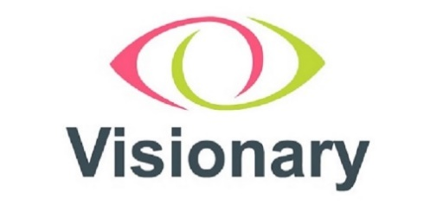

# Visionary country and regional meeting reps and Visionary leads

The table below lists the Visionary leads and Country and Regional Reps.

|  |  |  |
| --- | --- | --- |
| **Country / Region** | **Country / Region Reps** | **Visionary Leads** |
| **East of England** | Sharon Schaffer, Support for Sight | Fiona Sandford and  Raquel Garrido-Soriano |
| **Midlands** | TBC | Amy Pearman and  Nina Chesworth |
| **North East** | Sarah French, Vision & Hearing Support | Amy Pearman and  Raquel Garrido-Soriano |
| **North West** | David Anderson, Accrington & District Blind Society | Amy Pearman and  Nina Chesworth |
| **South East and London** | Eithne Rynne, Kent Association for the Blind  and Susanette Mansour, Croydon Vision | Fiona Sandford |
| **South West** | Jackie Sopwith, Somerset Sight and  Mike Silvey, Sight Support West of England | Fiona Sandford |
| **Yorkshire** | Scott Jobson, MySight York | Amy Pearman |
| **Scotland** | Jacquie Winning, Forth Valley Sensory Centre and  Lesley Carcary, Seescape | Fiona Sandford and  Raquel Garrido-Soriano |
| **Wales** | Rebecca Phillips, Wales Council of the Blind | Fiona Sandford |

End