# Annual Impact Report

**2022/2023**

# VI Charity Sector Partnership

#### Annual Impact Report 2022/2023

**VI Charity Sector Partnership**

**Contents Page**

Executive Summary 3

VI Charity Sector Partnership 4

Context 5

Workplan for 2022/2023 6

## Strategic Workstreams:

## Sight Loss Pathway including the Paediatric Pathway 7

* Post clinical support for people with sight loss 12

## VI Insight Hub 13

## Operational Workstreams:

## Mental Health and Wellbeing 15

## Talent Development and Lived Experience Leadership 16

## Employment  19

## Access to Technology 20

## Business as Usual:

## Crisis Response Plan 23

## Sector Information Sharing 25

## Joint Awareness Raising and Campaigning 28

Crisis Response

* Ukraine War 31
* Cost-of-Living 33

Events 36

Future plans for 2023/2024 39

Conclusion 39

Contact Details 39

#### Executive Summary

Eight of the leading charities in the sight loss sector form the VI Charity Sector Partnership. The partners are: Blind Veterans UK, Glaucoma UK, Guide Dogs, Macular Society, Retina UK, RNIB, Thomas Pocklington Trust and Visionary. Chaired by Matt Stringer, CEO, since its inception 2022 to 2023 was the second year of business with strategic and operational workstreams, business as usual, and crisis responses, forming the basis of activity. This report details this year’s activity and significant achievements which included:

* A Sight Loss Pathway mapping out patient support needs ensuring those diagnosed with sight loss or any other related eye health conditions can access information and support throughout their journey. A Paediatric Vision Impairment Support Pathway for England has also been developed.
* Established a post clinical support for people with sight loss (habilitation and rehabilitation) workstream to commission research into improvements in post-clinical support and then implement the findings.
* Collaborative funding for the development of a VI Insight Hub to collate insights, evidence, and statistics about the lives of blind and partially sighted people that will lead to greater understanding of sight loss, the barriers VI people face and the solutions that will help.
* Advanced the knowledge of the emotional impact of sight loss and upskilled mainstream professionals to improve support for those affected by sight.
* Developed a programme of work to increase the numbers of people with lived experience of sight loss employed at all levels in the sector, with a particular focus of increasing the numbers in leadership positions. Also, expanded the number of employment opportunities and services resulting in more people staying in work.
* Developing the Tech Selector Tool to provide technology information and advice for blind and partially sighted people resulting in the best experience and meeting individual needs.
* Provided a timely response to issues emerging around the war in Ukraine including those fleeing the conflict.
* Responded to the rising cost-of-living by coming together as ‘One Voice’ to achieve greater influence and policy change ensuring the experiences of blind and partially sighted people were acted upon and people knew about their entitlements and sources of support.

The report demonstrates the power and effectiveness of sector collaboration and the outcomes that can be achieved, and importantly highlights the impact for blind and partially sighted people and those at risk of sight loss. As we approach three years since the formation of the VI Charity Sector Partnership, we are embarking on a strategic review to further elevate our strategic ambition, develop a firmer identity, and ensure we are fit for purpose going forward.

#### VI Charity Sector Partnership

Eight of the leading charities in the sight loss sector formed the VI Charity Sector Partnership. The founding partners are: Blind Veterans UK, Glaucoma UK, Guide Dogs, Macular Society, Retina UK, RNIB, Thomas Pocklington Trust and Visionary. Chaired by Matt Stringer, CEO, RNIB. The purpose of the partnership is to provide strategic overview of initiatives that will lead to improving the lives of blind and partially sighted people and those at risk of sight loss across the UK.

#### Context

The coronavirus crisis resulted in the sector rallying together to address the challenges being faced by blind and partially sighted people. At the outset of the lockdown a Sector Coronavirus Response Group was formed comprising of the main sight loss charities. The group collaborated on issues such as access to food, mental health and wellbeing, accessible information, and social distancing. As the pandemic progressed the group tackled challenges due to ongoing lockdowns including pressures on sight loss organisations’ service delivery staff, the roll-out of the vaccination programme and home schooling of children and young people with visual impairment. The group demonstrated the benefits of collaboration and the added value that it can bring. It also addressed the challenges of sector working along the way. A commitment was made to continue to work in this way, partly driven by the closure of Vision UK. Partnership models were considered, and the preferred approach was an informal partnership under a memorandum of understanding. Not having a formally structured entity enabled the benefits of partnership working while recognising the autonomy and authority of organisations to work independently at scale and speed for the benefit of their client groups.

The VI Charity Sector Partnership was formed in October 2020, and one of the first initiatives was partners supporting the Sight Loss Charter developed by Visionary which aims to help everyone understand the ethos we agree to adopt in working together, creating a foundation stone to build sector relationships.

#### Workplan for 2022/2023

Thematic areas were assigned one of the three priority categories: strategic, operational, or business as usual as listed below.

Strategic priorities:

* Sight Loss Pathway (including Post Clinical Support)
* VI Insight Hub

Operational priorities:

* Mental health and wellbeing
* Talent development and lived experience leadership (including Employment)
* Access to technology

Business as usual:

* Crisis Response Plan
* Sector information sharing Kickstarter
* Joint awareness raising and campaigning

Also, the partnership has addressed responses to crises, such as Ukraine and the cost-of-living crisis. Each workstream comprises of an operational lead and sector working group. Interested parties from within the sight loss sector and beyond also contribute to the workstreams. Some of the workstreams also have a CEO sponsor.

Each workstream has provided more detail on the purpose of the workstream theme, the main activities undertaken in 2022/2023, an example to demonstrate the effectiveness of sector collaboration, and finally the impact for blind and partially sighted people and those at risk of sight loss.

## Strategic Workstream: Sight Loss Pathway

Workstream Leads: Robert Cooper, RNIB, and Phil Amber, RNIB

**Purpose of the workstream theme:**

Creating an end-to-end patient support pathway. There is currently no consistent end-to-end support ’Pathway’ for people in the UK with sight loss or other related eye health conditions. We want to develop a support ‘Pathway’ which allows those diagnosed with sight loss or any other related eye health conditions to understand, manage, and have access to information and support throughout their journey - from potential diagnosis, to regaining confidence and resilience around ‘living well’ with changes in sight. Two groups have been established to progress the work. Group 1’s focus is on Pre-Hospital to Hospital and Group 2’s focus is on Hospital to Post Hospital.

**Main activities undertaken in 2022/2023:**

1. RNIB and Group 1 partners have worked with a design agency, Kinneir Dufort, to understand the ‘pain points’ along the pathway and map the end-to-end pathway process, recognising that this pathway is not linear, and people enter, exit and re-enter the pathway, depending on their condition and situation.
2. The pathway was co-designed working with people with lived experience, wider third sector partners, Governments, NHS, Social Care and professional bodies. Initial feedback from key stakeholders across the sector:

Louisa Wickham, National Clinical Director for Eye Care (England)

“The pathway is so clearly laid out and I really like the way it extends into the community and social care pathway. This will be a very useful guide for the development of future services.”

Richard Ashcroft, Associate Director NHS Digital

“The outputs look excellent and well structured.”

Melanie Hingorani, UK Ophthalmology Alliance (UKOA)

“I am very supportive of what we are working together to try and achieve with this support pathway work, I am happy to share with UKOA members when appropriate for consultation and feedback.”

Guide Dogs Feedback Carl Freeman:

“Fantastic piece of work, much greater depth than has been produced previously.”

Donna O'Brien, SeeAbility

“Thanks so much for sharing the materials on the Sight Loss Pathway it’s such a great piece of work.”

1. Group 2 scoped charity partners engagement with health and social care systems to inform strategic thinking. Thematic mapping of all partners engagement provided a clear overview of activity and opportunities. There was consensus for ongoing sharing of activity related to health and social care engagement with opportunities to undertake joint working where appropriate and effective.

**An example to demonstrate the effectiveness of sector collaboration:**

Throughout September to November 2022 there were more than thirty in-person and online conversation sessions held, as well as one to one phone calls. All of the participants were blind or partially sighted. The sessions were set up and/or facilitated by sight loss organisations. In total almost four hundred people were engaged with, and sessions ran across the whole of the UK. Examples of feedback included:

“You need help and support quickly – if not you can be in the wilderness for some time.”

“People need to be put in the know about local provision, not knowing what is out there is the hardest thing.”

Scoping charity partners engagement with health and social care systems has achieved a greater understanding of the full range of activities provided. This illustrates the strength of the sector in service delivery, influencing and representing the voice of blind and partially sighted people when engaging with health and social care. It also presents the opportunity to strengthen signposting through increased understanding.

**The impact for blind and partially sighted people and those at risk of sight loss:**

This is the first time the end-to-end Eyecare, and Sight Loss Pathway has been mapped out with patient support needs identified at each stage. This knowledge can now be utilised in various ways to ensure those diagnosed with sight loss or any other related eye health conditions can understand, manage, and have access to information and support throughout their journey – from potential diagnosis, to regaining confidence and resilience around ‘living well’ with changes in sight.

## Strategic Workstream: Paediatric Pathway

Workstream Lead: Helen Honstvet, Guide Dogs

**Purpose of the workstream theme:**

Develop a Paediatric Vision Impairment Support Pathway for England to create consistency of access to services and support for children with a vision impairment. The aim is the use the Pathway to influence commissioners and government to ensure consistent provision in England and end the postcode lottery of provision.

**Main activities undertaken in 2022/2023:**

1. Ran a series of interviews and workshops to gather insights on what elements should be included in a Paediatric Vision Impairment Support Pathway for England.
   1. 14 x 1-2-1 interviews took place with representatives from the VI sector, health, and local authorities.
   2. Representatives from sight loss sector, education, professional bodies, and local authorities, participated in a sector workshop and provided ongoing feedback on the Pathway contents.
   3. Hosted a commissioner workshop which 21 commissioners from across the UK attended to feed into the Pathway.
   4. Delivered two lived experience workshops to gather feedback from parents of the pathway and their experiences.
2. Finalised the content for the Paediatric Vision Impairment Support Pathway for England – main audience is commissioners.
3. Finalised a parent facing document to accompany the Paediatric Vision Impairment Support Pathway for England.

**An example to demonstrate the effectiveness of sector collaboration:**

We held a workshop to gather in-depth insight from sector experts. This included representatives from Guide Dogs, RNIB, National Sensory Impairment Partnership (NatSIP), VIEW (The professional association for the Vision Impairment Education Workforce), and two local authorities. This was incredibly valuable in ensuring the Pathway was informed by the in-depth policy expertise and knowledge these sector representatives have. We used the feedback from this session to design the Pathway. We also continued to share the Pathway with the participants from this group as it developed following further consultation sessions to gain critical feedback and ensure the Pathway was the best it could be.

**The impact for blind and partially sighted people and those at risk of sight loss:**

We have been able to use the consultation process to develop relationships with commissioners and highlight the variable experiences of children with a vision impairment. 2023/2024 will see the influencing stage of this work take place.

## Strategic Workstream: Post clinical support for people with sight loss (habilitation and rehabilitation)

Workstream Lead: Nicky Shaw, Blind Veterans UK, and Fiona Sandford, Visionary

**Purpose of the workstream theme:**

Aim: All people with VI have the independence they need to live the life they choose.

Purpose: to examine why, at a fundamental level, rehabilitation/ habilitation support is broken across the UK and to present evidence of findings and develop recommendations from this.

**Main activities undertaken in 2022/2023:**

1. The Post clinical support for people with sight loss (habilitation and rehabilitation) (PCSPHR) was formally adopted as a programme in November 2022.
2. Two phases of work have been agreed. Phase 1: a research commission accompanied by a cross sector working group into measures that can be taken to improve post-clinical support in the here and now. Phase 2: the implementation phase plans to build on the findings of the research commission and ‘here and now’ discoveries.
3. The research commission documentation has been socialised and tested within a rehabilitation/habilitation working group meeting and with key stakeholders to refine its scope. Recommendations include:

* Separating the commission into two distinct pieces of research; one focusing on post-clinical support for adults with sight loss (rehabilitation) and one focusing on post-clinical support for children with sight loss (habilitation). The commission will be made sequentially.
* Emphasising lived experience through storytelling, centralising the voice of the service user at the heart of the research.
* A systematised approach, which fundamentally and radically reconsiders the current approach.

1. Applications have been made to funding bodies to generate funding to pay for the Phase 1 research commission and we await results.

**An example to demonstrate the effectiveness of sector collaboration:**

The workstream has brought together leaders from Blind Veterans UK, Guide Dogs, RNIB, and Visionary, in consultation with Rehabilitation Workers Professional Network, to fundamentally start to reconsider the system of post-clinical support generating contributions and influence towards the research commission as well as plans to collaborate to address shorter-term challenges.

**The impact for blind and partially sighted people and those at risk of sight loss:**

The PCSPHR work is in its initial stages of planning and therefore the impact has not yet been realised.

## Strategic Workstream: VI Insight Hub

Workstream Lead: Hilary Ingleton, RNIB

CEO Sponsor: Charles Colquhoun, Thomas Pocklington Trust

**Purpose of the workstream theme:**

To create a central hub collating insights, evidence, and statistics about the lives of blind and partially sighted people – a single trusted source of truth for the whole sector (and beyond) to use.

**Main activities undertaken in 2022/2023:**

1. Funding for the development of the VI Insight Hub awarded to BRAVO VICTOR. They have been involved in the creation of a similar hub for the veterans’ community.
2. Funding and collaboration agreements put in place between the eight charity partner organisations and BRAVO VICTOR. A total of £225,000 to jointly fund the platform and staff resource requirements for a minimum of two years.
3. Governance structure agreed with the creation of a Steering Group and Content Working Group.
4. Decisions taken on branding and name of hub: ‘VI Insight Hub’. Web platform under development.
5. Employment has been selected as the first topic for inclusion and development of the content is underway.

**An example to demonstrate the effectiveness of sector collaboration:**

The call to action to provide any insights relating to Employment to feed into the evidence review for the first topic resulted in a large number of high-quality insights being supplied from right across the sector. We are therefore confident that the evidence review will deliver a depth and breadth of insight on this topic that we have never previously had in one place.

**The impact for blind and partially sighted people and those at risk of sight loss:**

While there has been no impact on blind and partially sighted people yet, and there won’t be until after the hub is launched, long term the ambition of the hub is that it will lead to greater understanding (across the sector, partners, academia) of sight loss, the barriers VI people face and the solutions that will help them adapt, and that this will lead to better planning, provision and services for all blind and partially sighted people, and enable them to lead more independent and fulfilling lives.

## Operational Workstream: Mental Health and Wellbeing

Workstream Lead: Amanda Hawkins, RNIB

CEO Sponsor: Tom Wright, Guide Dogs

**Purpose of the workstream theme:**

To promote, plan and collaborate on services for the emotional impact of sight loss across the sector and to influence provision in the NHS.

**Main activities undertaken in 2022/2023:**

1. Upskilling of sector front-line staff on the emotional impact of sight loss. To date we have upskilled 219 frontline staff (2021-2022 stood at 86).
2. Planning and building mental health support capacity for children and young people affected by sight loss by a curriculum for school-based counsellors. To date we have written the curriculum and delivered a pilot with £80,000 funding from the Northern Ireland Department of Health.
3. Upskilling generically trained counsellors to be able to provide a sight loss informed service to people who are affected by sight loss. To date we have upskilled 255 counsellors (2021-2022 stood at 54).
4. Develop a training suite for allied mental health professionals within the NHS so they can support people with a visual impairment at the point of contact or to help move them into appropriate service, this is still in development.

**An example to demonstrate the effectiveness of sector collaboration:**

An example of the effectiveness of the collaboration has been to start to look at educating the allied health professionals. These include Ophthalmologists, GPs, Nurses, Counsellors, Psychiatrists, Dentists, Opticians, Care staff etc, all staff that will routinely come into contact with people with a visual impairment and be a point of contact for supporting better mental health. By working collaboratively, we have been able to map out what already exists across the sector, identify gaps, and devise a plan for implementation including pooling existing resources. Whilst this is in development, we believe this is likely to have a huge impact on raising awareness around the emotional and mental health impact and open pathways of support from within the NHS structure. We also aim to work with Royal Colleges or professional bodies to ensure that mental health awareness is embedded in professional guidelines.

**The impact for blind and partially sighted people and those at risk of sight loss:**

In both the children and young people and adult arenas we are building knowledge of the emotional impact of sight loss and supporting professionals to help people affected by sight loss to get the support when they need it. We are articulating the primary importance of the psychological and mental health impact of sight loss. Before it was an ‘add on’ or an afterthought, however, the sector is now routinely using the ‘emotional impact’ as a starting point to develop support.

## Operational Workstream: Talent Development and Lived Experience Leadership

Workstream Lead: David Aldwinckle, RNIB

CEO Sponsor: Fiona Sandford, Visionary

**Purpose of the workstream theme:**

The overall aim is to increase the numbers of people with lived experience of sight loss employed at all levels in the sector, with a particular focus of increasing the numbers in leadership positions of all kinds including but not limited to senior executive positions.

**Main activities undertaken in 2022/2023:**

1. The main activities this year have focussed on sharing current practices, understanding our baseline position, and working out how to best implement the approved recommendations. This has been challenging due to each working group member’s workload, along with the scale and complexity of this subject.
2. We have now agreed a full programme of work which we estimate will take between 18 and 24 months. The full programme approved by the partnership in February 2023, includes:

* Establishing and collecting common data sets to describe the recruitment, promotion, and departures of people with sight loss.
* Piloting a two-tier leadership programme that focusses on leading with lived experience available to every employee in any sector organisation. This will include a mid-range leadership qualification for mass participation, and a more bespoke, fast-track senior leadership programme with a high-quality business school.
* A national conference for all staff with sight loss across the sector aimed at better networking and connecting individuals and providing access to existing senior managers with lived experience of sight loss.
* Creating a single online platform to provide an authentic representation of working in the sector with sight loss, access to peer connection, mentoring, employment support and advice, employment and internship opportunities, and access to training provided by sight loss charities and our partners.

**An example to demonstrate the effectiveness of sector collaboration:**

As a first step towards consistently higher standards in employment of people with sight loss, each organisation has achieved or is in the process of achieving RNIB’s Visibly Better Employer quality standard. Alongside the standard support from RNIB’s Employment Team, the ability to collaborate and share experience amongst the different charities has been beneficial.

**The impact for blind and partially sighted people and those at risk of sight loss:**

Thomas Pocklington Trust and Visionary have both been awarded the RNIB’s Visibly Better Employer quality standard to charity partners. The Visibly Better Employer is about becoming a better and more inclusive employer for people with sight loss through aligning their working practices to the standard. The aim is to increase the number of blind and partially sighted people who apply for job opportunities, and they are able to confidently retain existing staff who develop sight loss.

## Operational Workstream: Employment

Workstream Lead: Martin O’Kane, RNIB

**Purpose of the workstream theme:**

The Employment subgroup seeks to bring together charity partners involved or interested in employment matters to share resources and information, to collaborate on operational and campaigning matters to magnify partners’ impact in supporting blind and partially sighted people to gain or retain employment.

**Main activities undertaken in 2022/2023:**

1. Pooled resource to support 21 new internships under the Thomas Pocklington Trust led scheme ‘Get Set Progress’ involving a diverse range of roles across 20 sight loss organisations throughout the UK. This is an opportunity for blind or partially sighted people to secure that first rung on the career ladder or for those who are returning to work following a career break. Increasing the total number of placements, their duration, and the support for those on placement to secure long term employment.
2. Joint work to address delays in Access to Work, sharing customer case studies, information on numbers of people facing delays engaged with each organisation, agreeing joint messaging for Ministers, developing a joint process to support customers escalate complaints, access to support needed, and joint media activity.
3. Sharing information and access to one another’s resources and services, including pre-employment courses.

**An example to demonstrate the effectiveness of sector collaboration:**

The 21 blind and partially sighted people starting paid internships has been a terrific success. Likewise, recommendations for Access to Work developed by the partnership, have in part been adopted by Department of Work and Pensions, and we believe have contributed to the start of a reduction in waiting lists and delays facing customers. Our media activity also reached over 2 million people in total with messaging on the impact of delays.

**The impact for blind and partially sighted people and those at risk of sight loss:**

Expanded employment opportunities (through internships), a broader offer of support for many as we shared resources and services, more have stayed in work by joining up support for those struggling with Access to Work delays. Access to Work delays are starting to reduce in part through out campaigning and proposals.

## Operational Workstream: Access to Technology

Workstream Lead: Gary Brunskill, RNIB (until December 2022) then Marie Orpen, Guide Dogs

CEO Sponsor: Matt Stringer, RNIB

**Purpose of the workstream theme:**

The purpose of the workstream is to maximise the opportunities for blind and partially sighted people to access technology and gain essential digital skills; as well as advocate and support their involvement through the development of inclusive products and services in wider society. Key workstream activity includes:

* The Tech Selector Tool to meet a customer need by providing a digital repository of technology and digital application information to help support people with sight loss.
* Upskilling of Vision Rehabilitation Specialists in technology.
* Development and publication of the Local Authority Digital Strategy Guidance document.

**Main activities undertaken in 2022/2023:**

1. The structure of the Tech Selector Tool platform, including questions and determined pathways, has been created and is currently being refined ready for web development. An expert panel has been established to review the selector tool. Content has been planned for production with relevant subject matter expert assistance and search engine optimisation, as well as the integration with VitalTech from Thomas Pocklington Trust.
2. Delivery of 4 sessions by Outlookers, hosted by Visionary, to 80 people, as well as access afterwards online. The subjects covered were magnification, screen readers, iOS and Android systems and an introduction to Microsoft. Specialists’ knowledge was developed on appropriate apps to support orientation and mobility, on technologies that support independent living skills, and managing the home.
3. We published a guidance document for local authorities, “Sight Loss and Local Digital Strategy Engagement: How blind and partially sighted people can bridge the digital divide” to encourage councils to fully consider the needs of people with vision impairment when developing their digital strategies.

**An example to demonstrate the effectiveness of sector collaboration:**

The idea for the Tech Selector Tool was borne out of the sector working group and since this Guide Dogs have been working collaboratively with Thomas Pocklington Trust and TAVIP (The Technology Association of Visually Impaired People) to produce the tool. A larger sector strategy around technology training will also ensure there are no gaps around the country. The guidance document for local authorities was shared at a workshop at the September 2022 Visionary Conference as local sight loss colleagues are ideally placed to engage with local authorities.

**The impact for blind and partially sighted people and those at risk of sight loss:**

Once launched the Tech Selector Tool will provide technology information and advice for blind and partially sighted people and those at risk of sight loss in a user-friendly setting. The use of an innovative digital selector tool allows people to receive a personalised and engaging experience. This tool will also be useful for front line staff and Access to Work advisors complimented by training to develop staff skills and resources to provide the best experience for the service user and meet their individual requirements.

## Business as Usual: Crisis Response Plan

Workstream Lead: Aaron Garrett, Blind Veterans UK

CEO Sponsor: Nicky Shaw, Blind Veterans UK

**Purpose of the workstream theme:**

The Crisis Response Plan was developed in response to the need for a joint approach when offering support to blind and partially sighted people with the emerging issues presenting through the coronavirus crisis. The plan aims to ensure that:

1. Blind and partially sighted people and those at risk of sight loss, maintain physical and emotional wellbeing during any future crisis.
2. The voice, needs, and experiences of people who are blind, partially sighted or at risk of sight loss, are heard and understood by government, service providers and policy makers in times of crisis.

The Crisis Response Plan is set to enable a rapid and co-ordinated approach as well as remaining agile in response to any new challenges. It is recognised that to achieve this outcome, the sector requires a collaborative approach to ensure coverage, avoid duplication, and offer a rapid, streamlined experience for people with sight loss in the event of a crisis. This is achieved by regular communication between charity partners, beneficiary feedback and guidance from the devolved nations. In addition, formal annual reviews and simulation exercises will take place to ensure the Plan remains responsive and fit for purpose in the future.

**Main activities undertaken in 2022/2023:**

1. Desktop exercise to review the content of the Crisis Response Plan and to make the documents more succinct and accessible. This has allowed us to identify wider areas of impact in the event of a crisis.
2. Wider discussions with the partnership have led to the identification of focussed issues for exploration which could cause a potential crisis situation. Examples include the impact on our client base of the increased cost of living, the anticipated energy blackouts, and the industrial action taken by key workers and the impact this has on services. Future ‘focus groups’ will be arranged to explore current emerging themes, allowing organisations within the partnership to be on the front foot with considering a contingency plan for potential crisis situations.
3. A simulation exercise took place in 2022, which was used to inform a local and national response to the coronavirus pandemic. This exercise utilised case studies which have explored changes to Government and societal restrictions relating to safe practice. This has allowed us to consider our organisational responses as a collective partnership to ensure we are providing rapid and agile information and resources to people with sight loss, where needed.
4. The Crisis Response Plan although borne out of the coronavirus crisis, will continue to inform a rapid response to a multitude of scenarios and therefore it is proposed that whilst the plan itself becomes a standard tool for future requirement, that testing through the process of simulation and desktop exercises will ensure that the plan remains live and relevant.

**An example to demonstrate the effectiveness of sector collaboration:**

By sharing our collective knowledge and understanding of the impact of the cost-of-living increases, we collaborated to produce advice and resources to assist and inform our client base, along with coordinated high impact awareness raising days, led by the RNIB. Representatives from each of the VI Charity Sector Partnership and the wider VI and disability sector have shared content and learning to take learning back to their own organisation. By incorporating this learning and using information to strengthen our messaging we are better informing blind and partially sighted people who engage with our individual and collective organisations of the support that may be available to them.

**The impact for blind and partially sighted people and those at risk of sight loss:**

The very nature of working with a Crisis Response Plan means that organisations within the VI Charity Sector Partnership are working together to consider joint responses, shared communications, and resources where appropriate to enable people who are blind, partially sighted or at risk of sight loss, to receive a streamlined, consistent, and rapid approach when accessing information and guidance in a presenting crisis situation. By working collaboratively, partner organisations have been able to reduce duplication in information sharing and provide a timely approach to campaigning and service delivery.

## Business as Usual: Sector Information Sharing

Workstream Lead: Debbie Newman, RNIB

**Purpose of the workstream theme:**

Promote the benefits of using  [Sightline](https://www.sightlinedirectory.org.uk/) an online directory of services and organisations that can help and support blind and partially sighted people in the UK. The directory is maintained by RNIB.

Promote [Sight Advice FAQ](https://www.sightadvicefaq.org.uk/) which answers questions about living with sight loss, eye health, or being newly diagnosed with a sight condition.

**Main activities undertaken in 2022/2023:**

### Sightline Directory - comparison for the period 1 April 2022 to 1 March 2023 (current year) against 1 April 2021 to 1 March 2022 (previous year).

* Unique page views: 150,435 (previous year: 192,670).
* Average time spent on the page: 1 minute 57 seconds (previous year: 1 minute 49 seconds).
* Next page pathway: RNIB sightline search results 15,004 (previous year 12,526).
* Channels driving engagement – Google is highest with most other traffic coming via direct use of site, Bing, and the RNIB website.
* Engagement by age group: 45-54 highest, with 35-44 coming close second, and 18 – 24 was the lowest range.
* Top google search terms: health, hospital, and eye clinic
* Devices used to access the directory: desk top devices were the most used.

### Changes during 2022 – 2023 included 555 organisations updated and reviewed, 17 new organisations added. Sightline Directory moved to new platform with a range of pre move actions completed to ensure it catered properly to the needs of both internal and external users. Actions included focus groups, feedback gathering through questionnaires and interactive meetings, feedback on accessibility, and testing.

### Sight Advice FAQ, these figures are in a slightly different format to the Sightline Directory and are from January - December comparison of 2022 against 2021:

* 180,595 sessions - up 37% on previous year.
* 163,023 unique visitors - up 35% on previous year.
* 5,090 searches - down 9% on previous year.
* 289,201 article views - up 33% on previous year.
* 76.5% positive article rating - down 2% on last year (above 50% is classed as outstanding so we are still very happy with this despite the slight downturn).
* 6,736 article ratings - up 57%.
* 276 pieces of feedback - up 36% on previous year.

### Changes during 2022 – 2023 included changes to the Cookie banner from non-interactive, to interactive to allow us to collate more data and hopefully enhance reporting. Over 800 questions were reviewed 470 of which were updated. 276 pieces of feedback were reviewed and acted on as needed. 96 new questions were created.

**An example to demonstrate the effectiveness of sector collaboration:**

In relation to Sightline Directory, we worked with Guide Dogs to ensure their 21 listings were up to date, Age UK to ensure that each branch identified had the correct services listed to properly reflect the offer provided and BID sensory support services to update all their local services to ensure they were listed correctly. In relation to Sight Advice FAQ, we worked with Retina UK to enhance content around eye research and genetic eye conditions and the impact of them.

**The impact for blind and partially sighted people and those at risk of sight loss:**

### Sightline Directory time spent on page increased which meant longer engagement with site. Previously the biggest engagement driver was through direct use (i.e., people with existing knowledge of the site). Now the biggest driver is Google search, which will be widening our reach. Going forward the move to the new platform will improve user experience (including accessibility improvements) and provide a more streamlined journey for submitting updates and requesting additions.

### Sight Advice FAQ sessions and visitors have both increased this year with article views and feedback increasing. Positive feedback is very high at 76.5%. These increased figures show that usage and awareness are building, with customer satisfaction being high and very positive.

## Business as Usual: Joint Awareness Raising and Campaigning

Workstream Lead: Blanche Shackleton, Guide Dogs (until November 2022) then Eleanor Briggs, Guide Dogs

**Purpose of the workstream theme:**

The purpose of this work was as follows:

* Present a more unified voice in policy and campaigning work (for instance through joint letters/statements) and create opportunities to amplify the policy and campaign asks of individual partners.
* Avoid duplication or clashes by sharing plans and coordinating activities wherever feasible and provide opportunities for smaller organisations and their members to participate in campaigning.
* Explore opportunities to jointly organise and jointly host Parliamentary or other policy and campaign events.

**Main activities undertaken in 2022/2023:**

1. Embedding initiatives to improve co-ordination and joint working between members, including:

* Developing a shared calendar between Guide Dogs, TPT and RNIB to avoid clashes and to maximise opportunities to amplify each other’s messages (to be shared with wider partners soon).
* A priorities grid to show where Guide Dogs, TPT and RNIB are focussing, how we can support each other and areas where there may be opportunities for further collaboration.

1. Improved communication and information sharing through regular meetings between Guide Dogs, TPT and RNIB’s policy and campaigns leads and meetings of the joint awareness raising and campaigns group with all members of the VI Charity Sector Partnership and other interested organisations.
2. Cross-sector work on the cost-of living crisis led by RNIB to amplify this campaign. A shared statement was signed up to by all VI Charity Sector Partnership charities in October 2022, backing the call for benefits to rise in line with inflation in the Chancellor’s mid-term fiscal plan. There was further joint activity by the VI sector and national disability charities under the banner of #SupportCantWait which reached 2.5 million people on social media on 19 January 2023. A second activity held on 6 April 2023 was supported by 68 disability charities and reached over 2.2 million people, with our messages seen over 7.6 million times on our day of action.
3. Cross-sector work on children and young people’s (CYP) influencing work, including:
   * A co-ordinated approach to responding to the special educational needs and disabilities (SEND) Green Paper.
   * The launch of the new Curriculum Framework for CYP with Vision Impairment after extensive consultation across the sector.
   * Development of the CYP Pathway, involving interviews with representatives from across the sector and families with lived experience to ensure the pathway reflects a wide range of views and experiences.

**An example to demonstrate the effectiveness of sector collaboration:**

The sector came together to respond to the government's SEND review of support for CYP with disabilities. The CYPVI Network held meetings to discuss the implications of the Green Paper and agree priority asks. This process ensured that the views of organisations that weren’t making formal submissions were included in with those that were. It also enabled coordination on key sector messages to be included by responding organisations, for example, an ask on the Curriculum Framework for CYP with Vision Impairment. TPT, LOOK-UK, and Guide Dogs jointly ran focus groups with parents and young people with vision impairments.

**The impact for blind and partially sighted people and those at risk of sight loss:**

The government’s Improvement Plan published in response highlights the importance of the specialist workforce for CYP with sensory impairment, and the challenges facing this workforce. A new apprenticeship will be developed to enable more people to train as teachers with a mandatory qualification for sensory impairment, and further measures will be considered. The Improvement Plan shows the impact of our joint working; workforce challenges were highlighted in multiple sector submissions (RNIB, NatSIP, Guide Dogs) and so we welcome this, and will be seeking to build on this success.

#### Crisis Response: Ukraine War

Workstream Lead: Andrea Glover, RNIB

**Purpose of the workstream theme:**

Provide a timely response to issues emerging around the war in Ukraine including those fleeing the conflict. Our response to Ukraine has been two-fold, both in supporting blind and partially sighted people inUkraine and the surrounding Eastern European countries, and towards blind and partially sighted Ukrainian refugees arriving in the UK.

**Main activities undertaken in 2022/2023:**

1. The response focused on getting financial and practical help to those who needed it the most. We made cash donations of £35k to the European Blind Union (EBU) initiatives, supporting Ukrainian blind and partially sighted refugees displaced by the war. We also worked with 17 organisations across Eastern Europe and Ukraine, supplying £18,952 of equipment.
2. We provided support to the SOSW School in Poland who are sheltering a group of VI Ukrainian children and assisted with their request to visit the UK.
3. RNIB have also led on an international effort to deliver a Talking Book Service for Ukraine. This has been a collaborative effort across a number of charitable and corporate partners. The Android version of the application is currently being tested by Ukrainian organisations and RNIB testers. The iOS version is under construction. The application looks good, is working well and all menus have been translated into Ukrainian. A catalogue of 500 Ukrainian language audio books have been uploaded to the content store and can be downloaded via the application. Testing is due to be completed by the Spring at which point we should be in a position to agree a date for our partners in Ukraine to roll it out to their library members.
4. We provide a joined-up approach to blind and partially sighted Ukrainian refugees arriving in the UK. Between us we have offered a range of complementary services at a national and local level. We have also helped in signposting blind or partially sighted refugees to the most appropriate specialist support. £10k funds is available to provide free specialist equipment following a grant from Thomas Pocklington Trust. We have communicated our offer via the Government’s Welcome Pack, Local Authorities, and widely via other communication channels.
5. Also, as a result, the VI Charity Sector Partnership drew together an offer of practical and emotional support for all asylum seekers and refugees arriving in the UK from anywhere in the World.

**An example to demonstrate the effectiveness of sector collaboration:**

We were able to collaborate extensively with TPT to introduce them to SOSW School, Poland. This school was originally brought to RNIB’s attention after they had contacted Lord Blunkett. Our combined efforts saw them supported in Poland via the provision of funds to purchase white goods and basic kitchen equipment as the school was struggling to cope with the influx of the children and family members. Collectively, RNIB, TPT and Guide Dogs contributed to a programme of activities for the children in the UK (organised and led by TPT) and provided online, educational resources. The airfare for this trip was contributed by the Duchess of York. The impact on the children to have a period of rest and relaxation in the UK after having undergone a highly stressful evacuation from Ukraine, separation from their families and the unfamiliarity of life in Poland cannot be underestimated. The children are part of a choir and the finale of their visit was a performance they gave at the TPT offices [performance by the Ukraine Blind School choir](https://eur03.safelinks.protection.outlook.com/?url=https%3A%2F%2Ftwitter.com%2FRNIB%2Fstatus%2F1603343352031854593&data=05%7C01%7CAndrea.Glover%40rnib.org.uk%7C3ee640ebb9e24886b34e08dadf47cb0f%7C5d45337cd19243fcaa5805557c9171bc%7C0%7C0%7C638067796693756097%7CUnknown%7CTWFpbGZsb3d8eyJWIjoiMC4wLjAwMDAiLCJQIjoiV2luMzIiLCJBTiI6Ik1haWwiLCJXVCI6Mn0%3D%7C3000%7C%7C%7C&sdata=d536eLKdmEJvnaXVWuqCNf5Zo9qCnHLj3DMCskPeDmU%3D&reserved=0).

**The impact for blind and partially sighted people and those at risk of sight loss:**

Our response provided financial and practical help, and emotional support, to blind and partially sighted people inUkraine and the surrounding Eastern European countries, and towards blind and partially sighted Ukrainian refugees arriving in the UK at a time they needed in the most.

#### Crisis Response: Cost-of-Living

Workstream Lead: Sophie Dodgeon, RNIB

**Purpose of the workstream theme:**

Evidence suggests that blind and partially sighted people are disproportionately affected by the rising cost-of-living. It is vital we keep speaking up loudly together so that the particular experiences of blind and partially sighted people are understood and acted upon by decision makers and we work together so that as many people with sight loss as possible hear about their entitlements and sources of support, and where they can access help if they are struggling.

**Main activities undertaken in 2022/2023:**

1. A shared statement was signed up to by all VI Charity Sector Partnership charities backing the call for benefits to rise in line with inflation ahead of the Chancellor’s mid-term fiscal plan in November. This was important given the proportion of blind and partially sighted people likely to be in receipt of means tested and disability benefits. We worked at pace to agree a media statement, and the item was shared widely across social media.
2. A short summary of collective support during the cost-of-living crisis was created for all charity partners to use, as well as content for the Sight Advice FAQ website, and a shared document itemising grants available from third parties which all organisations could publicise. A listing of warm spaces throughout areas of the UK was also incorporated.
3. VI Charity Sector Partnership charities played a central role in two days of action on social media by the VI sector and national disability charities, under the banner of #SupportCantWait. This emphasised how blind and partially sighted people, and disabled people, are particularly affected by high energy costs as well as the costs of their disability, and urgently need additional and targeted support.
4. Charity partner’s senior staff have also come together this year to discuss the impact of the cost-of-living on their organisations. Finance and Human Resources Leads met in November to discuss issues related to staffing and reward, volunteering, procurement, and an expected reduction in income from sources such as legacies. Information about nondomestic energy costs has been regularly shared to support smaller sight loss organisations with concerns over affordability.

**An example to demonstrate the effectiveness of sector collaboration:**

Our joined up social media activity under the banner of #SupportCantWait reached 2.5 million people on social media on 19 January 2023, supported by 14 national organisations and 25 Visionary members. A second activity held on 6 April 2023 was supported by a larger number of 68 disability charities, including 35 Visionary members, and reached over 2.2 million people, with our messages seen over 7.6 million times on our day of action. The action demonstrates the power of engaging charity partners as ‘One Voice’ to achieve greater influence and policy change.

**The impact for blind and partially sighted people and those at risk of sight loss:**

Our collective activities over the last six months have put the specific needs of blind and partially sighted people higher on the agenda of the Minister for Disabled People and parliamentarians, with examples of the additional costs of sight loss being communicated and first-hand accounts of people feeling forced to choose between heating and eating.

Our communications work has undoubtedly ensured that many more blind and partially sighted people are aware of the sources of support and grants which they may be entitled to.

#### Events

In May 2022, the VI Charity Sector Partnership Showcase Event highlighted the Annual Impact Report for 2021/2022 and demonstrated the effectiveness of the collaboration and importantly the impact for blind and partially sighted people and those at risk of sight loss. Delivered to a wider audience including Chairs and Trustees from the partners organisations. Feedback included:

“Delighted to join the VI Charity Sector Partnership Showcase. Great atmosphere of collaboration. Together we are greater than the sum of the parts. Fair to say we've made a really promising start - still lots to do!”

Anna Tylor, RNIB Chair

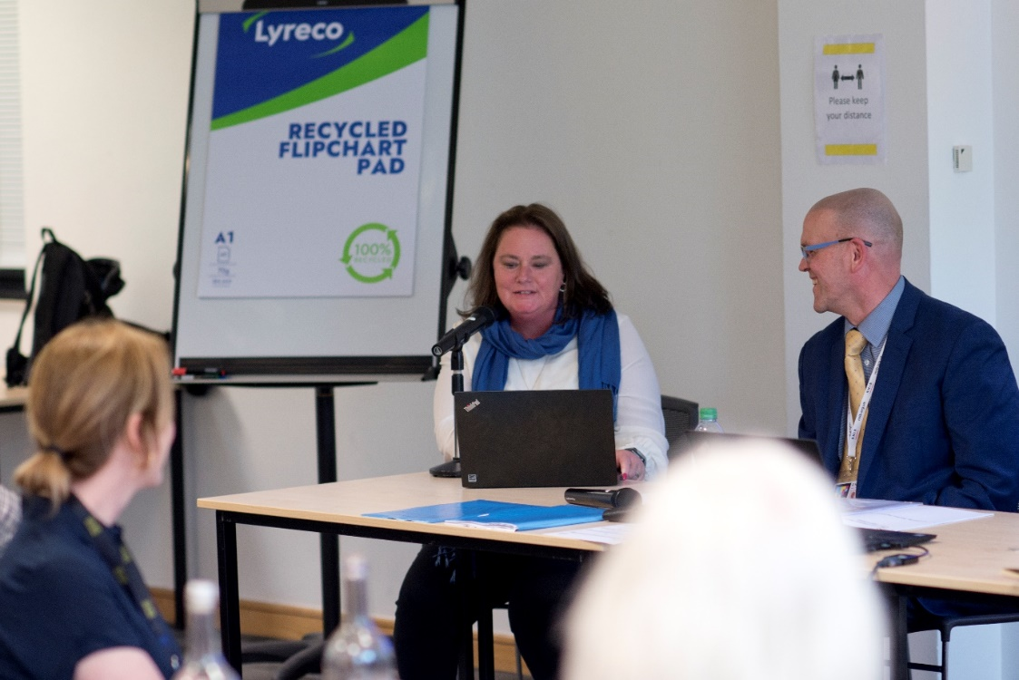

(Picture of Amanda Hawkins, Lead for the mental health and wellbeing workstream, seated at a table presenting to guests at the VI Charity Sector Partnership Showcase Event with Campbell Chalmers, Secretariat, to her right).

In October 2022, CEOs, and Senior Leaders across the eight charities attended a networking event organised by RNIB and kindly hosted by Mayer Brown. There was an insightful presentation by Juliet Bouverie, Chair of the Richmond Group and CEO of the Stroke Association. The event introduced the Senior Leadership teams to their counterparts to further increase productive and collaborative partnership working and subsequently there has been further engagement between Finance, Human Resources, and Communication Leads.

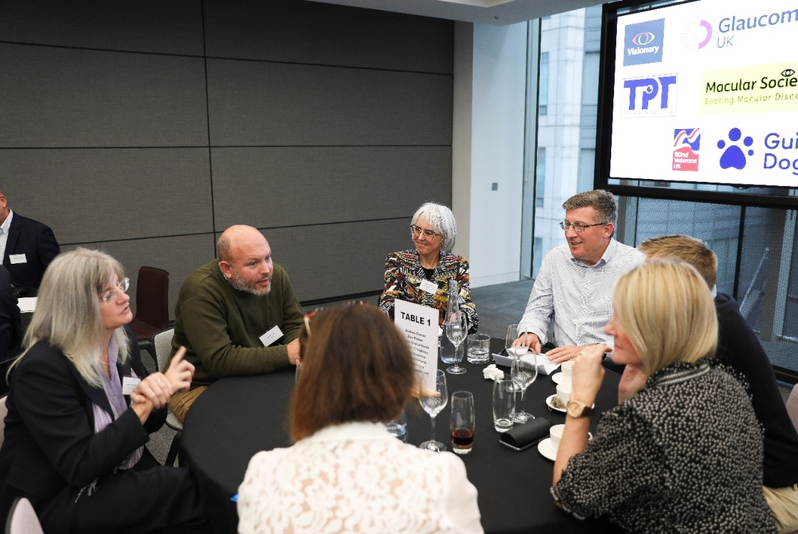

(Picture of guests seated round a table have a discussion at Mayer Brown premises with the charity logos visible on a TV screen in the background).

In March 2023, CEOs, and Senior Leaders across the eight charities attended a networking event organised and hosted by Guide Dogs. There were a number of short demonstrations and displays showcasing how trainers get dogs to perform key tasks, some of the sensory toys and equipment that habilitation specialists use to encourage vision impaired children and young people to develop life-skills, how a mobile app is making it easier for people with sight loss to report access refusals or detrimental changes to the built environment, and samples of the different types of tactile paving.

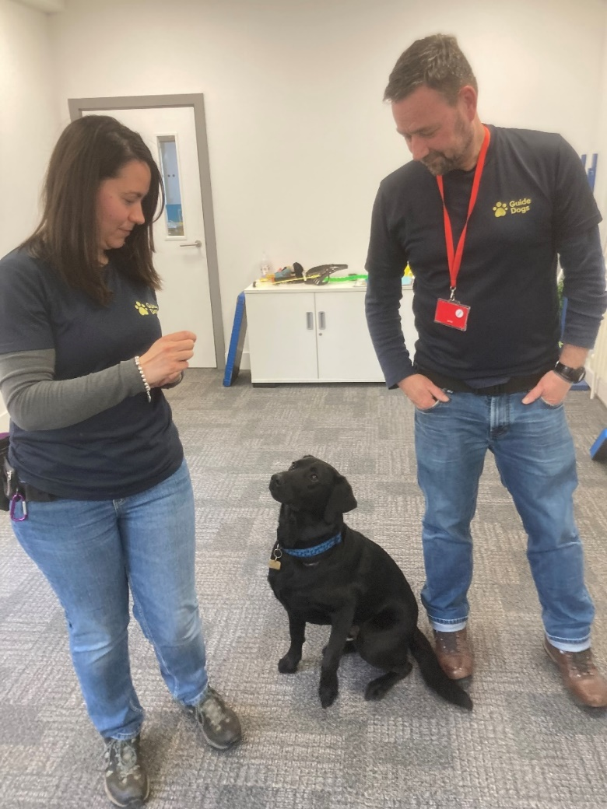

(Picture of two specialist trainers from Guide Dogs standing each side of ‘Dodger’ a black Labrador cross dog in training).

#### Future plans for 2022/2023

As we approach three years since the formation of the VI Charity Sector Partnership, partners remain positive about continuing to work collaboratively together. Recently there has been some challenges around ways of working therefore in the first two quarters of 2023 we are undertaking a strategic review to further elevate our strategic ambition, develop a firmer identity, and ensure we are fit for purpose going forward.

#### Conclusion

The VI Charity Sector Partnership has achieved significant outcomes and impact for blind and partially sighted people and those at risk of sight loss, with the momentum and potential to achieve more.

#### Contact Details

For further information about the VI Charity Sector Partnership or any of the activity please contact:

Campbell Chalmers, Strategic Engagement Lead – Third Sector, RNIB: [Campbell.Chalmers@rnib.org.uk](mailto:Campbell.Chalmers@rnib.org.uk)

Carl Freeman, Senior Collaboration Manager, Guide Dogs:

[Carl.Freeman@guidedogs.org.uk](mailto:Carl.Freeman@guidedogs.org.uk)

End of document.