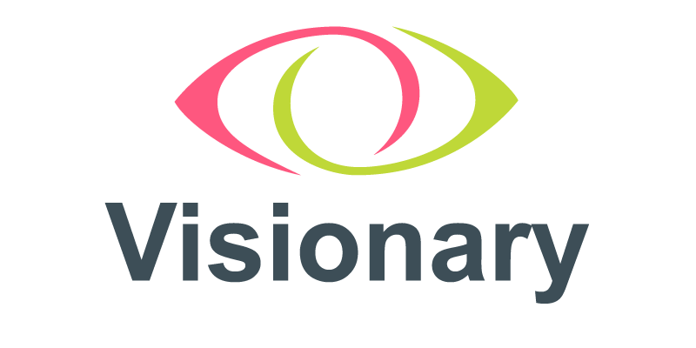

Projects, Campaigns, and Innovations Lead

Role Information and
Application Pack

Contents
About Visionary page 3
Job Description page 5
Person Specification page 11
How to apply for the role page 12

About Visionary
“We are a small organisation and having the connectedness into a bigger picture is worth its weight in gold - that’s what Visionary gives us.
Jacquie Winning, CEO, Forth Valley Sensory Centre
Visionary is a membership organisation for local independent charities that support blind and partially sighted people across the UK. These independent local charities provide practical, on the ground, services for local people with sight loss. Bringing together a wealth of experience and expertise in the sector, Visionary acts as the collective voice for local organisations.

Visionary believes that by local organisations working closely with national charities we will be stronger as a sight loss sector and positioned to make the biggest difference to blind and partially sighted people. Working together in partnership and sharing knowledge, we can have a stronger unified voice and be part of creating a stronger sight loss sector.
We encourage and support sharing across our network, make connections between people and organisations and support the development of services, strategies, partnerships, and collaborations. All with the aim of improving services and support for blind and partially sighted people. Our strategy and associated workstreams for 2022 – 2025 is included in this information pack.

Structure of Visionary

“Though she be but little she is fierce.”
Helena, A Midsummers Night Dream, William Shakespeare

We like to think of ourselves as a small but perfectly formed team! We are a group of creative, completer finishers. We are people who enjoy a good policy or two, love a beautiful diagram and a description with lots of adjectives!

What brings us together are shared values, respect for each other and the people and organisations we work with. We all want to make the world a better place and we have created a flexible structure which allows us to play to our strengths and be able to respond to a frequently changing external environment.

Visionary’s Organisational Chart

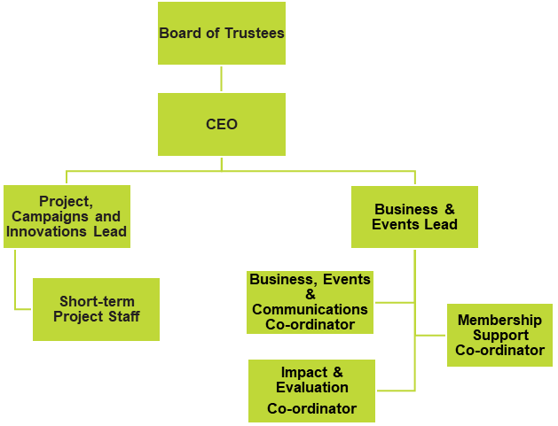

Description of Chart
The organisation chart above has the Board of Trustees at the top and the CEO underneath reporting to the Board of Trustees. The Project, Campaigns and Innovations Lead and Business & Events Lead are line managed by the CEO.
Short term project staff are line managed by the Project, Campaigns, and Innovations Lead.
The Membership Support Co-ordinator, Business, Events and Communications Co-ordinator and Impact and Evaluation Co-ordinator report to the Business and Events Lead.

Job Description
Position: Project, Campaigns, and Innovations Lead
Responsible to: Chief Executive Officer
Responsible for: Short term project staff
Salary: £38,000 per annum (pro rata to 28 hours per week)
Hours: 28 hours per week
Contract: Permanent
Location: Home based
With a requirement of employment that the post holder be prepared to work at any additional or different locations as may be necessary. The role involves regular travel throughout the UK with overnight stays a necessity.

Job Purpose
The main purpose of this and all Visionary roles, is to play an active and influential part in improving the local sight loss sector so that blind and partially sighted people have equality of opportunity, wherever they are in the UK.
Visionary is an agent for positive change within the sector and all roles are part of that. This role will work with sight loss organisations to create collaborative opportunities, deliver on projects, and support members to become involved in local and national campaigning issues.
A key part of this role is to form strategic partnerships that connect members and partners with each other and with appropriate external organisations. This includes developing projects with outcomes that make a positive difference to lives of blind and partially sighted people and fulfil the aspirations of all stakeholders. This role will also identify funders who might help create collaborative projects which strengthen the sector and enhance the offering to visually impaired people.
A vital element of everyone’s role at Visionary, along with our members, is to highlight the importance of people with lived experience being involved, heard and central in our work.

Main duties and responsibilities
We are a responsive organisation, and the needs of our members often change. Job descriptions and duties are therefore also subject to change to allow us to meet do what our member’s need us to do. The following list is intended to give you an idea of key priorities for the coming strategic period. This post will lead on:
Projects
- Identify members who want to connect, learn from each other and with them, create collaborative, funded projects.
- Identify, explore, and create opportunities for Visionary members and partners.
- Support member groups to come together to develop ideas.
- Identify funding sources and work with members to apply for funding for collaborative projects.
- Support the delivery of collaborative projects.
- Share the learning from this work and use it as leverage to create further activity.
- Celebrate the impact and success of projects and innovations by sharing via our channels of communication.

Some areas of work, which have already been identified as potential projects are:
- BAME and LGTBQ+ communities about the barriers they experience when accessing sight loss organisations.
- supporting members to recognise and embed structures and practices which embrace lived experience expertise.

Campaigns
- Identify and support members who want to become actively involved in campaigning, including eye health and prevention. This could include working with local members and national partners to achieve shared objectives and offer support locally.
- Share the learning and outcome of campaigns across the Visionary network.
- Celebrate the impact and success of campaigns by sharing via our channels of communication.

Developing relationships
- Work alongside colleagues to develop relationships across Visionary’s network.
- In response to member’s need, develop strategic partnership within the sight loss sector and beyond.
- Attend specific regional and country meetings to hear what our members and partners are saying.
- Attend Members Consultative Group (MCG) and Members and Partners Consultative Group (MPCG) meetings to listen and learn and make the links. Follow up on the links with actions and feedback.
- Support, attend, contribute, and vocalise the member’s voice to the VI Charity Sector Partnership workstreams (categories to be agreed, depending on the skills of the successful candidate).
- Identification of new Visionary members and partners.
- Work with colleagues to promote Visionary’s offer.

Impact and Evaluation
- Follow up and evaluate the connections made between members and partners, to understand the difference made to blind and partially sighted people through Visionary’s work.
- Follow up on Visionary interactions to find out what happened and create an understanding of the outcomes and impact. Share this information as required.
- Use our customer relationship management system (Salesforce) to ensure accurate and relevant information is gathered, stored, and used to good effect.
- Ensure the data collected by the team is in line with member, partner, and funder requirements.
- Report on identified themes and trends as required, including reporting at the Members Consultative Group (MCG) and Members and Partners Consultative Group (MPCG).
- Identify and write up case studies relating to the difference made through support from Visionary.
- Conduct annual members visits identified by the Business and Events Lead.

Annual Conference
- Support the Business and Events lead to plan and deliver Visionary’s Annual Conference.
- Work with the Visionary team to create an annual conference which is engaging and creates new opportunities for Visionary members and partners.
- It is a requirement of this role that you will be available and attend the Visionary Annual Conference, each year.

Online Sessions
- Facilitate and deliver Visionary on-line sessions including the Fundraisers Forum.

General
- Provide support and advice to members.
- Have responsibility for particular geographical areas – including attending, facilitating and organising of country and regional meetings.
- Carry out annual visits with members in your geographical areas.
- Assist with the design, organisation and delivery of our events, sessions, and annual conferences.

With colleagues you will:
- assist with recording and demonstrating impact measurement.
- monitor and evidence outcomes.
- analyse Visionary’s activities.
- make recommendations for change and improvement.
- gather and share good news stories.
- participate in our generic information service.
- support our commitment to lived experience leadership (opens PDF).
- support our involvement in the VI Charity Sector Partnership – including involvement in workstream activity.
- Any other duties that may require you to deputise for a colleague, represent Visionary or that fall within the remit of this role.

Where this post fits within the Visionary team
We have a team approach to our work and how we deliver it. Everyone has a valid role to play, which is respected and recognised. We play to our strengths and seek support with our weaknesses. You have a responsibility to yourself and your colleagues to do your job and to help your colleagues do theirs.
You are a creative force within the team. You are one of the people who comes up with ideas – generated from what you have heard our members say. You make the links between members and partners and follow up on these links. You take your colleagues with you, evidencing the positive difference, changes, or new ways of working with blind and partially sighted people.
You are responsible for creating collaborative ventures between members and partners. You are responsible for working with them to seek out funding sources and applying to those sources. You are responsible for working with members and partners to deliver successful projects.
You are responsible for involving local member organisations with our national partner campaigns.You make the links, connect the relevant people with each other and follow up on what happens next.
Sometimes we create resources from our work to share with the network.You will help create and share these resources.
When we need to gather data, or ensure we are compliant with guidance or legislation, you will work with colleagues and make that happen.
We are a funded organisation and we are accountable for how we spend our money. You will work with your colleagues, in particular the CEO, to produce reports, analysis and whatever is necessary to ensure we comply with existing grants and are in a good position to secure future funding.
And it goes without saying (although we are saying it!) at all times, you will remain within the set budget and adhere to the boundaries we set.

Reporting and Accountability
You will report to the CEO and where appropriate, to the Board of Trustees on all relevant activity. This will include supporting the CEO in preparation of all relevant reports, including reports to our funders, board reports and financial reports.
You will be accountable for Visionary’s compliance with our own policies, procedures and quality standards and also any appropriate external regulatory requirements and standards. You will ensure that policies and procedures are reviewed on a regular basis to provide fit for purpose guidance.
You will be accountable for the supervision, support and development of short term project staff.
You are expected to contribute to the wider strategic development of the charity and be a role model in the demonstration of Visionary’s values and competencies.

About You
What kind of person likes to work at Visionary?
First and foremost, you should have a desire for social change. You might not fully understand the importance of people with lived experience being in control of their own destiny – but you should want to find out why that is a good thing!
You will be someone who likes to work with others, listen and hear and come up with a plan, if indeed a plan is what is needed. You should be able to make links and connections between people and be happy to share what you know with your colleagues and the organisations we work with. It’s not about showing off what you know, it’s about finding out what people don’t know and exploring with them how to find things out.
If you are open to new ideas and feel comfortable with change, you are probably going to be ok. If you like the same routine every day, you are less likely to be happy. Finally – we like to laugh and have fun!

Person Specification

Knowledge and Skills

Essential:
- Good understanding of the sight loss sector and challenges local organisations face.
- Excellent communication and influencing skills, including written and presentation.
- A free and creative thinker, adept at finding solutions and ideas in response to challenges.
- Strategic with the ability to spot and assess new opportunities for collaboration and impact.
- Excellent organisational skills with the ability to manage your own workload, work independently and achieve results without close supervision in relation to a varied portfolio.
- Proven ability to work with diverse groups of people.
- Proven ability to develop effective relationships with a wide range of people and organisations.
- A track record of taking projects from idea to action, to completion.

Desirable:
- Knowledge of joint campaigning and awareness raising.

Experience

Essential:
- Experience developing and implementing creative projects, initiatives and services in the voluntary/public sector.
- Experience developing successful funding bids.
- Track record of leading the development of effective partnerships and collaborations across a range of organisations/groups/sectors.
- Experience identifying opportunities and new ways of working.
- Experience of monitoring, reporting and deadline management.

Desirable
- Lived experience of visual impairment.
- Demonstrable experience scaling up a project to reach or be taken on by a wider organisation/s.
- Participation in campaigning and awareness raising.
- Experience of managing and motivating staff and volunteers.

Personal qualities

Essential:
- Commitment to Visionary’s values, mission and purpose.
- Approachable and easy to talk to.
- Collaborative approach and ability to build effective relationships with a wide range of people.
- Versatile and flexible - open to new ideas and comfortable with change.
- Willing to listen, learn and adapt.
- Open and honest.
- Comfortable working independently and managing own workload across a range of priorities.
- Creative.
- Thoughtful.
- Ability to follow through / completer/finisher.
- Independent but likes to be part of a team.

How to apply for the role
To apply for this role please send your CV with covering letter, of no more than 600 words, outlining how you meet the person specifications and why you are the best person for this role to amy.pearman@visionary.org.uk by 5pm on Tuesday 28 February 2023.
Initial Interviews will be held on Wednesday 15 and Thursday 16 March 2023.
If you have any questions or would like an informal discussion about the role, please do not hesitate to get in touch via email, visionary@visionary.org.uk and we will be in touch.
We look forward to hearing from you.
Document Ends.

