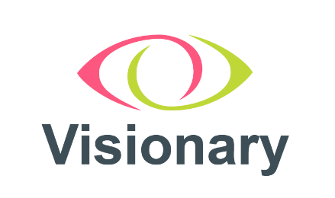

Visionary Equal Opportunities Form
Visionary wants to meet the aims and commitments set out in its equality policy. This includes not discriminating under the Equality Act 2010 and building an accurate picture of the make-up of the workforce in encouraging equality and diversity.
The organisation needs your help and co-operation to enable it to do this but filling in this form is voluntary. The information provided will be kept confidential and will be used for monitoring purposes.
Please return the completed form to amy.pearman@visionary.org.uk
If you have any questions about this form or would like assistance completing the form, please email Amy Pearman (amy.pearman@visionary.org.uk).

- Do you consider yourself disabled, as defined by the 2010 Equality Act?
Yes
No
Prefer not to say

If you would like to share more information about your disability or health condition or reasonable adjustments you may require, please tell us here:

The information in this form is for monitoring purposes only. If you believe you need a reasonable adjustment, then please discuss this with your manager, or the manager running the recruitment process if you are a job applicant.

- Your gender:
Male
Female
Intersex
Non-binary
Prefer not to say
If you prefer to use your own gender identity, please share it here:

Is the gender you identify with the same as your gender registered at birth?
Yes
No
Prefer not to say

- Age:
16-24
25-34
35-44
45-54
55-64
65-74
75+
Prefer not to say

- Please specify your ethnic group (or leave blank if you prefer)

- Please specify your religion or belief (or leave blank if you prefer)

- Please specify your sexual orientation (or leave blank if you prefer)

- Do you have caring responsibilities?

If yes, please indicate all that apply

Primary carer of a child/children (under 18)
Primary carer of a disabled child/children
Primary carer of a disabled adult
Primary carer of an older person/people
Secondary carer
Prefer not to say

Document ends.

